
REDHILL PRIMARY ACADEMY

Child Protection and Safeguarding Policy

Commitment to review

This policy will be flexible to change and will be reviewed on an ongoing basis to reflect where there are any changes in government legislation or any changes in the duty of statutory agencies in child protection and/or the wider safeguarding agenda. If it is not appropriate to refine the policy during the year, then this will be done as a matter of course on yearly basis by a named person responsible below, who shall be accountable for that action.

Child Protection Policy and Safeguarding Policy 2024-25 - Document Status
Date published by Telford and Wrekin Safeguarding Partnership: | 2 September 2024 | Authors: | Telford & Wrekin Council, Education Safeguarding Team
Date of policy creation: | September 2024 | Person responsible for creation: | Claire Whiting
Date of policy inception: | September 2024
Date of policy adoption by Local governing Board | Subject to LGB approval on November 2024
Date of policy review for 2024/25: | September 2025 | Person responsible for review: | Claire Whiting

Our safeguarding team
Designated Safeguarding Lead and Online Safety Lead | Claire Whiting
Designated teacher for looked-after and previously looked after children | Lisa Williams
Early Help Lead | Denise Rock
Deputy Designated Safeguarding Lead  CSE Lead | Lydia Cartwright
Deputy Designated Safeguarding Lead | Amy Coughlan
Deputy Designated Safeguarding Lead | Sam Farmer
Deputy Designated Safeguarding Lead - Nursery | Sarah Thorpe
Deputy Designated Safeguarding Lead - Nursery | Miranda Briscoe
Deputy Designated Safeguarding Lead | Nikki Bell-Ward
Deputy Designated Safeguarding Lead – non -teaching team/pastoral team | Faye Bailey
Academy Trust Safeguarding Governor | Phil Nicholls
Prevent Governor | Phil Nicholls

At Redhill Primary Academy the protection of children is the responsibility of everyone. One of our core responsibilities is to ensure the school community feels safe and that they belong.

Below is a snapshot of some of the ways in which we ensure safety is paramount in our academy.



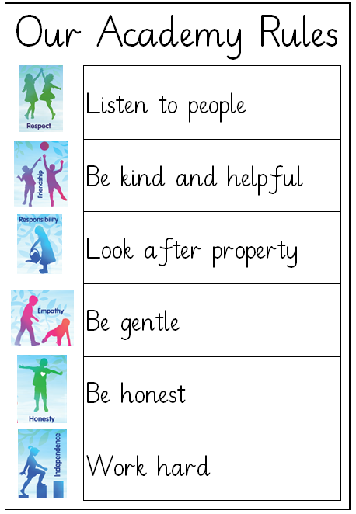

Our core values system: A Valued Me, alongside our academy rules, ensure that children are kept safe and belong within our community.

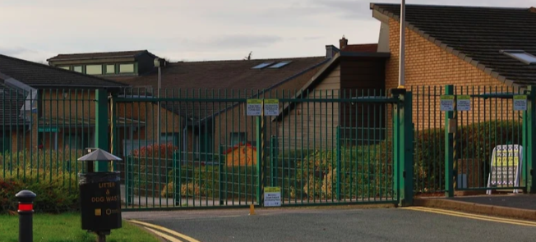

The academy site is secure with fob entry access onto the grounds and coded door systems and passes required for

entry. All access points are secured and locked.
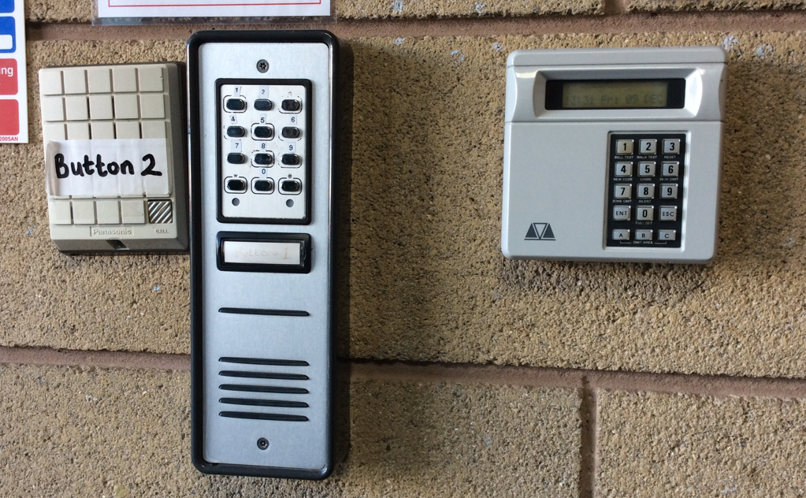

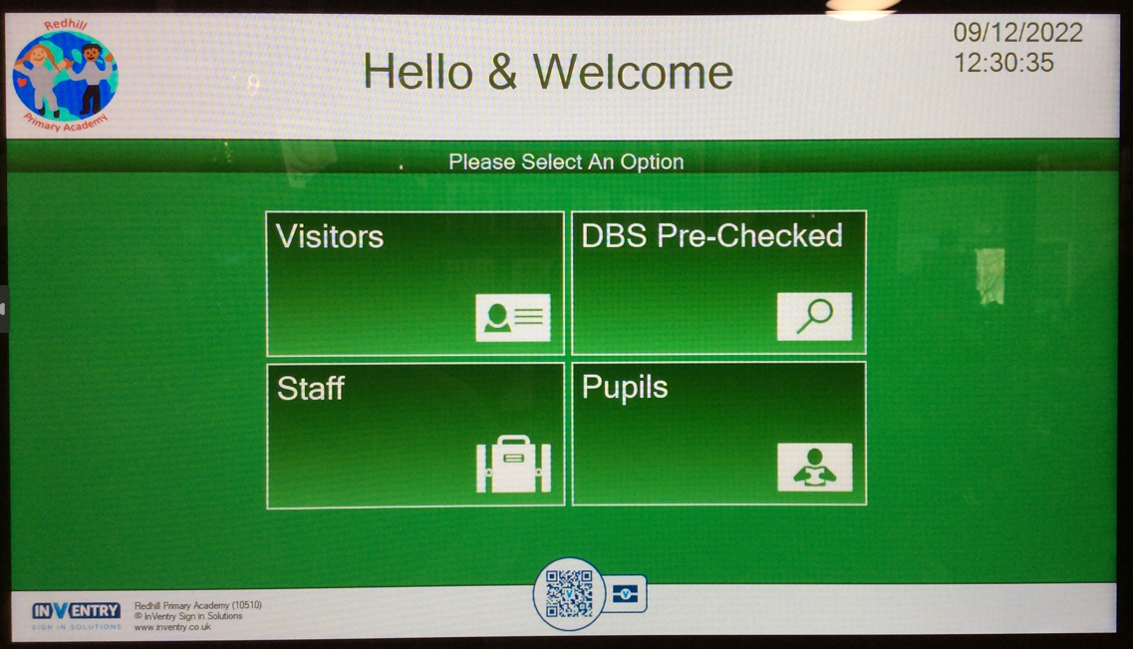
Lanyards are worn by all members of the academy staff.

Visitors are required to sign in using our Inventory system, identification is then checked, and the visitor is then provided with a visitor’s pass. We have tried and tested our lanyard system to check pupils understand the protocol: acting if they see a visitor without a lanyard or if the visitor is unaccompanied wearing a yellow lanyard.

We have a racist and bullying incident book which are kept in the Headteacher’s office. Any type of abuse, racism and/or bullying are not tolerated at Redhill.

Every term, the Headteacher plans a fire alarm practice, invacuations and evacuations, to ensure that all children and staff know exactly what to do in case of a real fire or emergency situation.

A number of our pupil voice groups, help to keep us safe.

Our S.A.F.E committee (Safe and Friendly Environments) are a group of eight, years 5 and 6 children who are chosen by class teachers and Mrs Coughlan for their empathetic and sensible nature. Mrs Coughlan trains this group in counselling skills and works with them on safeguarding issues including online safety. A safeguarding suitcase has been set up so all children can post their worries on a slip, and this is then responded to by the committee or Mrs Coughlan depending on the nature of the worry. S.A.F.E deliver assemblies, for example, PANTS, and write top tips for classroom display on safeguarding themes including keeping safe when working online, using apps and games. S.A.F.E committee is identified by their green bar badges in the academy. The S.A.F.E committee regularly undertake risk assessments and support the Headteacher and caretaker in Health and Safety walks around the academy. They produce leaflets and flyers to give to all children promoting subjects such as how to keep safe online, trusting reliable sources, online bullying etc. They are also fundamental in supporting the delivery of our annual E-safety week in February.

Our Travel Council is led by the Junior Road Safety Officers to promote all aspects of travel through regular assemblies and competitions, and the organisation of the annual Walk to School Week. The focus of this group is to encourage children to lead a healthier lifestyle and to promote safety awareness in the community.

Our No Outsiders group, led by Mrs Fance, are responsible for ensuring that everyone is treated equally regardless of their differences and ensuring that children have an understanding of protected characteristics. They regularly complete assemblies and organise charitable activities to promote and celebrate diversity within the community. They support the rest of the academy in ensuring that we are an inclusive environment, and that any discrimination or harassment will not be tolerated.

Our safeguarding approach

Intent

Safeguarding is at the heart of all that we do at Redhill Primary Academy. We are committed to ensuring the welfare and safety of all children and staff within the academy. Safeguarding is everyone’s responsibility, and all staff share the mindset that it could happen here.

Redhill Primary Academy is acutely aware of the local safeguarding risks within our local community alongside Telford and Wrekin Safeguarding Partnership priorities which includes early help, domestic abuse, neglect, exploitation, and child-on-child abuse. This ensures that we are able to fully support children and families in a timely manner.

We work hard to support our local community in whichever way we can, applying contextual safeguarding and working with families and agencies to bring about the best support for each and every case. Our inclusion manager and pastoral leads work alongside children and families, offering early intervention to minimise the need of crisis intervention.

Intentions of our offer -

• To support all pupils who may have been or are at risk of abuse.

• To establish and maintain an ethos where pupils feel safe and secure.

• All staff and governors are trained and fully committed to safeguarding and promoting the welfare of all pupils.

• Child Protection concerns are dealt with sensitively following policies and procedures in place.

• Promote the key principles outlined in the academy’s Relationships and Behaviour and Anti-Bullying Policies.

• Strive to create a school free of all kinds of discrimination, harassment, and intolerance.

• Develop safe practice amongst all our pupils, e.g. while using the internet, while engaged in potentially hazardous or unhealthy activities or with respect to issues that may arise from others in the local community.

• Foster an atmosphere in which children and young people feel safe, supported, and listened to when discussing their concerns about safeguarding issues.

• Instigate a rolling programme of evaluation and review with respect to safeguarding policies, practices and procedures.

• To offer Breakfast club, Wrap Around care and After School Clubs to support children and families.

• Support with uniform where needed.

• Support with attendance at school.

• Pastoral support – regular check-ins with children and meaningful interventions.

• Open door policy to our parents/carers to share any concerns or worries.

Implementation

Safeguarding in our school is the responsibility of all staff, governors, parents/carers and pupils. Staff and governors are committed to undergoing annual safeguarding training and have an awareness of the correct policies and procedures to follow when concerns arise. Regular internal safeguarding training, refreshers, bulletins and questionnaires are carried out with all members of staff at weekly staff or TA meetings. Safeguarding forms part of the staff meeting and the senior leadership (SLT) agenda. Weekly staff meetings and fortnightly SLT meetings are held to discuss concerns, provide updates and share good practice. Half termly full DSL meetings are held where there is time for supervision, problem solving and additional CPD and sharing of good practice.

We have a Health and Safety Governor committee which meets half termly. This committee involves lots of quality assurance activities including pupil voice, spot checking staffs’ knowledge and understanding of safeguarding policy and procedure and site walks. Safeguarding is also discussed as part of the full Local Governing Body meeting: this ensures that safeguarding remains a high priority, compliance is examined, and the culture of safeguarding is robust and effective.

We have an induction lead who meets and inducts all new admissions upon completion of paperwork. The induction process is robust and covers all aspects of safeguarding policy and procedure. The Deputy Headteacher then conducts a separate safeguarding training session in the first few weeks of employment, checking that key policy and procedure is embedded and offering an opportunity for any questions around safeguarding in the academy.

All DSLs, including the academy’s Inclusion Manager are experienced and trained to lead Early Help, this coupled with strong relationships with families increase the likelihood of vulnerable families taking up the Early Help offer.

We understand that supervision is a priority. We have a facility on our digital reporting system (CPOMS) which allows the reporter to click for supervision should they feel it needed.

The lead DSL along with the office manager are the named Attendance Champions who work closely with school support staff and the Education Welfare Officer EWO to monitor, remove and

respond to concerns regarding attendance.

Our curriculum is designed to support our priority around prevention linked to safeguarding. Safeguarding is carefully woven into our curriculum offer, ensuring that children have a broad understanding of how our school helps to keep them safe whilst in the classroom and beyond. Safeguarding is embedded within the academy’s curriculum offer through lessons, assemblies, themed days/weeks and focused workshops from external partners, e.g. NSPCC, provides pupils with the skills to equip them to stay safe and know how to respond to personal concerns. See below section on Opportunities to teach safeguarding for further details on page 40 - 52.

All incidents of child-on-child are reported without delay to a DSL, responding to such concerns is in line with the school’s child-on-child abuse policy and risk assessment.

Our S.A.F.E Committee are advocates for delivering important safeguarding messages e.g. PANTS rule, bullying to name but a few. Half termly assemblies led by the S.A.F.E Committee and/or DSLs links continually to safeguarding. We understand that children need to recall and retrieve information in order for them to know and remember more. These assemblies use video

clips, stories, role play and much more in order to ensure all children understand the important messages that are being relayed.

Safeguarding key messages are shared with parents/carers via the academy’s weekly newsletter, The Mail on Friday, and social media. Our DSL team send top tips out regularly to parents e.g. on E-safety and to staff as reminders on, for example, the importance of professional curiosity and record keeping.

Impact

Our staff, pupil and parent/carer questionnaires provide a reassuring picture that they feel safe at our academy. Recent parent questionnaires conducted in November 2023 demonstrate that 98% of parents surveyed would recommend our school. 97% of parents/carers state their child feels safe at our academy, 2% neither agree nor disagree and 1% disagree. The academy has worked diligently to build positive relationships with parents/carers, as such they feel reassured their voice will be heard and action will be taken to respond to concerns appropriately.

The academy’s effective safeguarding culture can be further evidence by a local authority audit in Spring 2024. Outcomes identify the school’s commitment to working collaboratively with external agencies/partners and responding in a timely manner when safeguarding incidents and concerns are raised. The children can confidently talk about safeguarding, what it means and who and what a DSL is. They are able to speak clearly about steps they can take to keep themselves safe and in and out of school.

The staff team provide data to develop routine reports to provide governors and LA representatives

monitoring the school current and accurate data relating to trends, local safeguarding risks and number of vulnerable children on safeguarding plans.

DSL meetings/supervisions provide a closer analysis of open/closed cases detailing action an outcome. This routine rolling schedule of meetings highlights the impact of policies and processes evidencing good practice.

At our academy, the impact of our safeguarding culture and practice is measured via, but not limited to:

• Attendance data

• Safeguarding audits

• Numbers of children on safeguarding plans

• Surveys and questionnaires for staff, pupils, parents/carers

• Incident statistics via CPOMS

• Behaviour

Summary & aims

- We have regard for the statutory guidance from the Department for Education (DfE) issued under Section 175 of the Education Act 2002 (as amended), the Education (Independent School Standards) Regulations 2014, the Non-Maintained Special Schools (England) Regulations 2015 and the Apprenticeships, Skills, Children and Learning Act 2002 (as amended). This policy has been developed in line with legal obligations, including, where applicable, the Human Rights Act 1998, the European Convention on Human Rights, the Domestic Abuse Act 2021, the Children and Social Work Act 2017, the Equality Act 2010 and the Public Sector Equality Duty. We will adhere to the statutory guidance Working Together to Safeguard Children 2023 and Keeping Children Safe in Education 2024 (KCSIE). We will follow the DfE of What to do if you are Worried a Child is Being Abused - Advice for Practitioners. We recognise the NSPCC website also provides us additional information on abuse, neglect, exploitation and what to look out for.

- We provide early years provision and adhere to the Statutory Framework for the Early Years Foundation Stage 2024 (EYFS).

- All child protection matters will be dealt with in line with the arrangements of Telford and Wrekin Safeguarding Partnership (TWSP) and West Midlands Child Protection and Safeguarding Procedures or, if relevant, the safeguarding partnership area children reside in, under the care of or with designated responsibility.

- This policy replaces the previous policy of April 2024.

- We have a duty of care to all pupils and their families, and staff, The safety and protection of all children is of paramount importance to all those involved in education. The aim of this policy is to make all within our setting feel safe, promote their welfare and have clear roles and responsibilities in place for that to happen. We are committed to inter-agency working to keep children safe. All of our community believe that our setting should provide a caring, positive, safe and stimulating environment, which promotes the social, physical and moral development of the individual child.

- The local governing board local governing board will ensure that all staff have read at least part one of KCSIE (or annex A if appropriate) and those working with children will also read Annex B of KCSIE. All members of the local governing board and the Designated Safeguarding Lead (DSL) and their deputies will read all parts of KCSIE, relevant parts of Working Together to Safeguard Children and Part three: safeguarding and welfare of the EYFS. We will maintain a record of this. We recognise that best practice would be for all staff to be acquainted with all parts of KCSIE. The local governing board will ensure that mechanisms are in place to assist staff to understand and discharge their role and responsibilities as set out in Part one (or Annex A if appropriate) of KCSIE.

- Our policy and all supplementary policies and procedures are published on our website for all to view.

Part one: Safeguarding information:

A child centred and coordinated approach to safeguarding

- All those who are part of our Academy, including our staff are an important part of the wider safeguarding system for our pupils.

- It is everyone’s responsibility to safeguard and promote the welfare of children; this includes everyone who comes into contact with children and their families. Everyone will consider, at all times, what is in the best interest for the child and ensure their practice is child centred. This responsibility is set out in all staff’s job descriptions.

- No one will manage concerns about a child in insolation. Everyone will identify concerns, share information and take prompt action to help children and families receive the right help at the right time.

- For the purpose of this policy, safeguarding and promoting the welfare of children is defined as:
- Providing help and support to meet the needs of children as soon as problems emerge;
- protecting children from maltreatment, whether that is within or outside the home, including online;
- preventing impairment of children’s mental and physical health or development;
- ensuring that children grow up in circumstances consistent with the provision of safe and effective care; and
- taking action to enable all children to have the best outcomes.

- ‘Children’ includes everyone under the age of 18.

The role of our staff

- Our staff will identify concerns early, provide help for children, promote children’s welfare and prevent concerns from escalating. They will provide a safe environment in which children can learn.

- We are committed to identifying children who may benefit from early help. Early help means providing support as soon as a problem emerges at any point in a child’s life.

- The DSL and their deputy’s role are to advise on safeguarding concerns, support others to carry out their safeguarding duties and liaise with other agencies.

- All teachers, including the Headteacher in accordance with the Teachers’ Standards 2012 will safeguard children’s well-being and maintain public trust in the teaching profession as part of their professional duties.

Staff training and induction

- All staff will receive an induction, so they are aware of our safeguarding systems. This will include the child protection policy, child-on-child abuse policy and procedures, behaviour policy, staff behaviour policy, safeguarding response to children who are absent from education and role of the DSL and CSE lead (including the identity of the DSL and any deputies). We will provide copies of policies and a copy of Part one (or Annex A, if appropriate) of KCSIE to all staff at induction. We will maintain a record of induction.

- Staff will receive appropriate safeguarding and child protection training (including online safety which, amongst other things, includes an understanding of the expectations, applicable roles and responsibilities in relation to filtering and monitoring) at induction. This training will be refreshed every three years. All staff will also receive at least annual child protection and safeguarding updates (including online safety), to provide them with relevant skills and knowledge to safeguard children effectively. All staff will receive annual training in child sexual exploitation awareness. We will ensure staff safeguarding training is integrated, aligned and considered as part of whole Academy safeguarding approach and wider staff training and curriculum planning and training helps staff to understand local safeguarding procedures. We will maintain a record of training.

- All staff will be made aware of the following:
- Telford & Wrekin early help process and their role within it;
- the process for making referrals to children’s social care and for statutory assessments under the Children Act 1989, especially section 17 (children in need) and section 47 (a child suffering, or likely to suffer, significant harm) and the role they might be expected to play in such assessments;
- what to do if a child tells them he/she is being abused, exploited or neglected;
- how to reassure victims they are being taken seriously and that they will be supported and kept safe;
- that children may not feel ready or know how to tell someone that they are being abused, exploited or neglected, and/or they may not recognise their experiences as harmful;
- staff should be professionally curious and speak to the DSL or their deputies if they have concerns about a child, and
- staff should build trusted relationships with children which facilitate communication.

- We will encourage staff to consider the TWSP briefing on professional curiosity.

- Staff know how to manage the requirement to maintain an appropriate level of confidentiality. This means only involving those who need to be involved, such as the DSL (or a deputy) and children’s social care. Staff will never promise a child that they will not tell anyone about a report of any form of abuse, neglect and/or exploitation because this may ultimately not be in the best interests of the child. All staff will reassure victims that they are being taken seriously and that they will be supported and kept safe. A victim will never be given the impression that they are creating a problem by reporting abuse, sexual violence or sexual harassment. Nor will a victim ever be made to feel ashamed for making a report. Staff will record how they have reassured victims.

Early help

- We believe that any child may benefit from early help, and we ensure that all staff are alert to the potential need for early help for a child who:
- is disabled or has certain health conditions and has specific additional needs;
- has special educational needs (whether or not they have a statutory Education, Health and Care Plan);
- has a mental health need
- is a young carer;
- is showing signs of being drawn in to anti-social or criminal behaviour, including gang involvement and association with organised crime groups or county lines;
- is frequently missing/goes missing from education, care or from home;
- has experienced multiple suspensions, is at risk of being permanently excluded from school or college and in Alternative Provision or a Pupil Referral Unit;
- is at risk of modern slavery, trafficking, sexual and/or criminal exploitation;
- has a parent or carer in custody, or is affected by parental offending;
- is in a family circumstance presenting challenges for the child, such as drug and alcohol misuse, adult mental health issues and domestic abuse;
- is misusing drugs or alcohol themselves;
- has returned home to their family from care;
- is at risk of so-called ‘honour’-based abuse, such as Female Genital Mutilation or Forced Marriage;
- is a privately fostered child; and
- is persistently absent from education, including persistent absences for part of the day.

- We ensure that all children that disclose that they have taken an overdose go to the Emergency Department at the nearest hospital to be checked by a medical professional in line with the TWSP Procedure for the management of overdoses, involving children within schools and colleges.

Early help at Redhill Primary Academy

Attendance
- Attendance data is monitored by assigned staff (Headteacher and School Attendance Officer).
- Regular reporting to Governors around attendance.
- Letters home at 95% attendance, followed up by warning letters.
- First day calling.
- Home visits for attendance concerns requiring investigation.
- Monitoring groups in high mobility or absence requests.
- School nursing service referrals for medical conditions that affect attendance.
- Return to school action planning with pastoral team.

Curriculum
- Access to one-to-one support, paired and group work where needed.
- Themed Assemblies.
- Interventions for vulnerable pupils.
- Key adult project for vulnerable pupils.
- Citizenship and PSHCE delivery.
- Inter-school events.
- Topics and themes driven by pupils' aspirations, relevance to both own culture and the local area, key questioning and development of language skills.
- Access to pastoral room and breakfast club before school.
- Access to after school clubs.

Financial Support
- Support with purchasing school uniform.
- Support in applying for free school meals funding (if applicable).
- Breakfast club and after school club bursaries.
- Signposting to local charities including food banks.

Staying Safe
- Relevant policies and procedures e.g. Safeguarding, Child Protection, Special Educational Needs and Disability, Relationships and Behaviour Policy, GDPR (General Data Protection Regulation), Staff Code of Conduct in place.
- Schools Advisory Service (SAS) support for staff mental health and well-being.
- Children’s Mental Health Toolkit / WRAP (Wellness Recovery Action Plan) and support from qualified Mental Health First Aiders.
- Advice point and Early Help response through pastoral team.
- Pupil voice groups e.g. SAFE committee, No Outsiders, E-Safety, Travel Council, Playground Friends etc.
- Assemblies on themes around staying safe e.g. ‘Stranger Danger’ 'Anti-bullying' ‘Pants’.
- Worry box available for all pupils.
- Care plans for vulnerable pupils and individual healthcare plans for pupils with medical needs regularly monitored and reviewed with SENCO.
- ‘Bikeability’ programme for road safety.
- PEEPs (Personal Evacuation Plans) and Risk assessments for vulnerable pupils.
- Family Connect for safeguarding concerns.
- Access to support for families living with domestic violence.
- Access to support for families living with alcohol or drugs abuse.
- E-safety policy and procedures and filtering system.
- Good links with PCSO (Police Community Support Officer).
- Parent workshops.
- PEP (Personal Education Plan) and LAC (Looked After Children) review meetings led by designated safeguarding teacher.
- PSHE curriculum (through Jigsaw, Respect Yourself and No Outsiders schemes of work).
- Prevent issues awareness and training for concerns around radicalisation.
- FGM (Female Genital Mutilation), CSE (Child Sexual exploitation), Forced marriages awareness and training, Sexual harassment and sexual violence training.
- School nurse drop-ins and referrals.
- Tracking, recording and analysis of incidents e.g. through CPOMS.
- Whole school safeguarding training.

Social, Emotional and Mental Health Needs
- Hearing what children have to say and using the voice of the child.
- Qualified Mental Health First Aiders (Denise Rock and Faye Bailey)
- ALGEE approach to Mental Health (Approach, Assess, Assist, Listen without judging, Give help and advice, Encourage outside support, Encourage support in school)
- Bereavement counselling available to pupils
- Referrals to CAMHS (Children, Adolescent Mental Health Service)
- Referrals to Educational Psychology Service
- Lego and play therapy support from Social Emotional and Mental Health Team
- Pastoral Support Programme including soft start for children from 8:15am and break time and lunchtime sessions
- Staff training in dyslexia, ADHD (Attention Deficit Hyperactivity Disorder), ASD (Autism)
- Access to Virtual School Team for Looked after Children
- Counselling service for school staff

Supporting Families
- Hearing what parents / carers have to say and building relationships with them.
- Raising awareness of safeguarding issues in the Mail on Friday weekly newsletter e.g. online safety.
- School tours and / or visit sessions.
- Curriculum days / evenings.
- Workshops with external visitors to support families in safeguarding e.g. exploitation and online safety.
- Parents evenings.
- Pastoral support.
- SENCO support for families of children with special educational needs or disability
- Access to SENDIASS (Special Educational Needs and Disabilities Information Advice Support Service).
- Signposting to external agencies and training.
- Using the Early Help Assessment.

The Local Community
- Community events e.g. school fair.
- Donations from community e.g. sponsored events.
- Community Links such as Fire, PCSO (Police Community Support Officer), Sports and local businesses.
- Religious groups.
- Supporting charities.

Transition
- Extra visits / induction for vulnerable students to their new school.
- Induction Days
- Pupil records passed from school to school.
- SENCO liaises with SENCOs from other schools to pass on records and information about pupils on the SEN Register.
- Transition programme with designated link teachers e.g. for pupils with special educational needs or disability, Children in Care.
- Visits for prospective families.
- Work with key partners.

Young carers

- Legislation defines a ‘young carer’ as ‘…a person under 18 who provides or intends to provide care for another person (of any age, except where that care is provided for payment, pursuant to a contract or as voluntary work).' A young carer might look after someone because they are sick or have a disability or mental health issues. Or, if a parent or family member has an alcohol or drug problem, they may be unable to care for themselves or anyone else.

- We recognise the responsibilities of young carers are wide and varied but can include:
- practical tasks, such as cooking, housework and shopping;
- physical care, like helping someone out of bed;
- emotional support, including talking to someone who is distressed;
- personal care, such as helping someone dress;
- managing the family budget and collecting prescriptions;
- helping to give medicine;
- helping someone communicate, and
- looking after brothers and sisters.

- Caring for someone can be very isolating, worrying and stressful for children. For young carers, this can negatively affect their experience in education. We recognise that many young carers will regularly miss Academy and that this can have a lasting effect on their life chances.

- Our aim is to work with families and other agencies to identify young carers to ensure that their needs are assessed and where necessary supported. We will work with the Telford and Wrekin Young Carers Service to do this.

Abuse, neglect and exploitation

- All staff are trained on the indicators of abuse, neglect and exploitation, and understand children can be at risk of harm inside and outside of our Academy, inside and outside of the home, and online. Staff will exercise professional curiosity and know what to look out for because this is vital for the early identification of abuse and neglect to identify cases of children who may be in need of help or protection.

- We believe that abuse, neglect, exploitation and safeguarding issues are rarely stand-alone events. All staff, but especially the DSL and their deputies will consider whether children are at risk of abuse or exploitation in situations outside their families. Extra-familiar harms take a variety of different forms and children can be vulnerable to multiple harms.

- All staff are aware that technology is a significant component in many safeguarding and well-being issues. We understand children are at risk of abuse online as well as face-to-face. In many cases, abuse will take place concurrently via both online and offline. Children can also abuse other children online, this can take the form of abusive, harassing, and misogynistic/misandrist messages, the non-consensual sharing of indecent images, especially around chat groups, and the sharing of abusive images and pornography, to those who do not want to receive such content.

- Abuse: a form of maltreatment of a child. Somebody may abuse or neglect a child by inflicting harm or by failing to act to prevent harm. Harm can include ill treatment that is not physical as well as the impact of witnessing ill treatment of others. This can be particularly relevant, for example, in relation to the impact on children of all forms of domestic abuse, including where they see, hear or experience its effects. Children may be abused in a family or in an institutional or community setting by those known to them or, more rarely, by others. Abuse can take place wholly online, or technology may be used to facilitate offline abuse. Children may be abused by an adult or adults or by another child or children.

- Physical abuse: a form of abuse which may involve hitting, shaking, throwing, poisoning, burning or scalding, drowning, suffocating or otherwise causing physical harm to a child. Physical harm may also be caused when a parent or carer fabricates the symptoms of, or deliberately induces, illness in a child. The fabrication or induction of illness (FII) in children is a relatively rare form of child abuse. Where concerns exist about FII, it requires professionals to work together, evaluating all the available evidence, in order to reach an understanding of the reasons for the child’s signs and symptoms of illness. At all times professionals need to keep an open mind to ensure that they have not missed a vital piece of information’. We adopt the guidance Safeguarding children in whom illness is fabricated or induced and TWSP FII Best Practice Guidance.

- Emotional abuse: the persistent emotional maltreatment of a child such as to cause severe and adverse effects on the child’s emotional development. It may involve conveying to a child that they are worthless or unloved, inadequate, or valued only insofar as they meet the needs of another person. It may include not giving the child opportunities to express their views, deliberately silencing them or ‘making fun’ of what they say or how they communicate. It may feature age or developmentally inappropriate expectations being imposed on children. These may include interactions that are beyond a child’s developmental capability as well as overprotection and limitation of exploration and learning or preventing the child from participating in normal social interaction. It may involve seeing or hearing the ill-treatment of another. It may involve serious bullying (including cyberbullying), causing children frequently to feel frightened or in danger, or the exploitation or corruption of children. Some level of emotional abuse is involved in all types of maltreatment of a child, although it may occur alone.

- Sexual abuse: involves forcing or enticing a child or young person to take part in sexual activities, not necessarily involving a high level of violence, whether or not the child is aware of what is happening. The activities may involve physical contact, including assault by penetration (for example rape or oral sex) or non-penetrative acts such as masturbation, kissing, rubbing and touching outside of clothing. They may also include non-contact activities, such as involving children in looking at, or in the production of, sexual images, watching sexual activities, encouraging children to behave in sexually inappropriate ways, or grooming a child in preparation for abuse. Sexual abuse can take place online, and technology can be used to facilitate offline abuse. Sexual abuse is not solely perpetrated by adult males. Women can also commit acts of sexual abuse, as can other children. The sexual abuse of children by other children is a specific safeguarding issue in education and all staff are aware of the settings policy and procedures of dealing with this.

- Neglect: the persistent failure to meet a child’s basic physical and/or psychological needs, likely to result in the serious impairment of the child’s health or development. Neglect may occur during pregnancy, for example, as a result of maternal substance abuse. Once a child is born, neglect may involve a parent or carer failing to: provide adequate food, clothing and shelter (including exclusion from home or abandonment); protect a child from physical and emotional harm or danger; ensure adequate supervision (including the use of inadequate caregivers); or ensure access to appropriate medical care or treatment. It may also include neglect of, or unresponsiveness to, a child’s basic emotional needs.

Safeguarding issues

- All staff are trained on safeguarding issues that can put children at risk of harm.

Child-on-child abuse

- All staff are aware that children can abuse other children. This can happen inside or outside of our setting and online.

- All staff will be trained in our policy and procedures with regard to child-on-child abuse and the important role they have to play in preventing it and responding to where they believe a child may be at risk from it.

- All staff understand that even if there are no reports in our setting it does not mean it is not happening, it maybe abuse is just not being reported. When staff have any concerns regarding child-on-child abuse, even if there are no reports in our setting, they should still speak to the DSL (or a deputy).

- All staff are expected to challenge inappropriate behaviours between peers, examples of which are listed below, that are actually abusive in nature. Downplaying certain behaviours, for example dismissing sexual harassment as “just banter”, “just having a laugh”, “part of growing up” or “boys being boys” can lead to a culture of unacceptable behaviours, an unsafe environment for children and in worst case scenarios a culture that normalises abuse leading to children accepting it as normal and not coming forward to report it.

- Child-on-child abuse is most likely to include, but may not be limited to:
- bullying (including cyberbullying, prejudice-based and discriminatory bullying);
- abuse in intimate personal relationships between children (sometimes known as ‘teenage relationship abuse’);
- physical abuse such as hitting, kicking, shaking, biting, hair pulling, or otherwise causing physical harm (this may include an element of online which facilitates, threatens and/or encourages physical abuse);
- sexual violence, such as rape, assault by penetration and sexual assault (this may include an online element which facilitates, threatens and/or encourages sexual violence);
- sexual harassment, such as sexual comments, remarks, jokes and online sexual harassment, which may be stand-alone or part of a broader pattern of abuse;
- causing someone to engage in sexual activity without consent, such as forcing someone to strip, touch themselves sexually, or to engage in sexual activity with a third party;
- consensual and non-consensual sharing of nudes and semi nudes images and or videos (also known as sexting or youth produced sexual imagery);
- upskirting, which typically involves taking a picture under a person’s clothing without their permission, with the intention of viewing their genitals or buttocks to obtain sexual gratification, or cause the victim humiliation, distress or alarm, and
- initiation/hazing type violence and rituals (this could include activities involving harassment, abuse or humiliation used as a way of initiating a person into a group and may also include an online element).

- We will actively seek to raise awareness of and prevent all forms of child-on-child abuse by:
- educating all governors, our senior leadership team, staff, students, and parents about this issue;
- educating children about the nature and prevalence of child-on-child abuse, positive, responsible and safe use of social media, and the unequivocal facts about consent, via the curriculum;
- engaging parents on these issues;
- supporting the on-going welfare of the student body by drawing on multiple resources that prioritise student mental health, and by providing in-Academy counselling and therapy to address underlying mental health needs;
- working with governors, senior leadership team, and all staff, students and parents to address equality issues, to promote positive values, and to encourage a culture of tolerance and respect amongst all members of the Academy community;
- creating conditions in which our students can aspire to, and realise, safe and healthy relationships fostering a whole-Academy culture;
- responding to cases of child-on-child abuse promptly and appropriately; and
- ensuring that all child-on-child abuse issues are fed back to the DSL and deputies so that they can spot and address any concerning trends and identify students who may be in need of additional support.

- We will actively engage with TWSP in relation to child-on-child abuse, and work closely with, for example, children’s social care, the police and other education settings. The relationships our setting has built with these partners is essential to ensuring that we are able to prevent, identify early, and appropriately handle cases of child-on-child abuse. The DSL (or a deputy) will regularly review behaviour incident logs which can help to identify any changes in behaviour and/or concerning patterns or trends at an early stage.

- We recognise that any child can be vulnerable to child-on-child abuse due to the strength of peer influence, especially during adolescence, and staff should be alert to signs of such abuse among all children. Individual and situational factors can increase a child’s vulnerability to abuse by their peers. We know that research suggests:
- child-on-child abuse may affect boys differently from girls (i.e. that it is more likely that girls will be victims and boys perpetrators). However, all child-on-child abuse is unacceptable and will be taken seriously;
- children with Special Educational Needs and/or Disabilities (SEND) are three times more likely to be abused than their peers without SEND, and
- some children may be more likely to experience child-on-child abuse than others as a result of certain characteristics such as sexual orientation, ethnicity, race or religious beliefs.
Child-on-child sexual violence and sexual harassment
- All those who are part of our community believe that sexual violence and sexual harassment is not acceptable and will not be tolerated.

- We understand that sexual violence and sexual harassment can occur between two or more children of any age and sex. It can occur online. It can also occur through a group of children sexually assaulting or sexually harassing a single child or group of children. Sexual violence and sexual harassment exist on a continuum and may overlap.

- We recognise that children who are victims of sexual violence and sexual harassment will likely find the experience stressful and distressing. This will, in all likelihood, adversely affect their educational attainment and will be exacerbated if the alleged perpetrator(s) attends our setting.

- We will work to ensure our Academy community are aware of the importance of:
- challenging inappropriate behaviours;
- making clear that sexual violence and sexual harassment is not acceptable, will never be tolerated and is not an inevitable part of growing up;
- not tolerating or dismissing sexual violence or sexual harassment; and,
- challenging physical behaviours (potentially criminal in nature), such as grabbing bottoms, breasts and genitalia, pulling down trousers, flicking bras and lifting up skirts. Dismissing or tolerating such behaviours risks normalising them.
- For the purpose of this policy, we use the term ‘victim’, ‘alleged perpetrator(s)’ or where appropriate ‘perpetrator(s)’. Ultimately, the use of appropriate terminology will be determined, as appropriate, on a case-by-case basis.

- Along with providing support to children who are victims of sexual violence or sexual harassment, we will provide the alleged perpetrator(s) with an education, safeguarding support as appropriate and implement any disciplinary sanctions. We recognise that a child abusing another child may be a sign they have been abused themselves or a sign of wider issues that require addressing within the culture of our setting. Taking disciplinary action and providing appropriate support, can, and should, occur at the same time if necessary.

- We understand that reports of sexual violence and sexual harassment are extremely complex to manage. We know it is essential that victims are protected, offered appropriate support and every effort is made to ensure their education is not disrupted. We also know it is also important that other children, adult students and our staff are supported and protected as appropriate.

- We will try to be aware of, and respond appropriately to all reports and concerns, including those outside of our setting, and or online.

- While the focus of this policy is on protecting and supporting children, we will of course protect any adults and engage with adult social care, support services and the police as required.
Sexual violence
- Our staff are aware of sexual violence and the fact children can, and sometimes do, abuse their peers in this way both inside and outside of our setting. We refer to sexual violence as sexual offences under the Sexual Offences Act 2003 as described below:

Rape: A person (A) commits an offence of rape if: he intentionally penetrates the vagina, anus or mouth of another person (B) with his penis, B does not consent to the penetration and A does not reasonably believe that B consents.

Assault by Penetration: A person (A) commits an offence if: s/he intentionally penetrates the vagina or anus of another person (B) with a part of her/his body or anything else, the penetration is sexual, B does not consent to the penetration and A does not reasonably believe that B consents.

Sexual Assault: A person (A) commits an offence of sexual assault if: s/he intentionally touches another person (B), the touching is sexual, B does not consent to the touching and A does not reasonably believe that B consents.

Causing someone to engage in sexual activity without consent: A person (A) commits an offence if: s/he intentionally causes another person (B) to engage in an activity, the activity is sexual, B does not consent to engaging in the activity, and A does not reasonably believe that B consents. (This could include forcing someone to strip, touch themselves sexually, or to engage in sexual activity with a third party.)

- We believe that consent is about having the freedom and capacity to choose. Consent to sexual activity may be given to one sort of sexual activity but not another, e.g.to vaginal but not anal sex or penetration with conditions, such as wearing a condom. Consent can be withdrawn at any time during sexual activity and each time activity occurs. Someone consents to vaginal, anal or oral penetration only if s/he agrees by choice to that penetration and has the freedom and capacity to make that choice.

- Sexual consent:
- a child under the age of 13 can never consent to any sexual activity;
- the age of consent is 16;
- sexual intercourse without consent is rape.
Sexual harassment
- When referring to sexual harassment we mean ‘unwanted conduct of a sexual nature’ that can occur online and offline, both inside and outside of our setting. When we reference sexual harassment, we do so in the context of child-on-child sexual harassment. Sexual harassment is likely to: violate a child’s dignity, and/or make them feel intimidated, degraded or humiliated and/or create a hostile, offensive or sexualised environment.

- While not intended to be an exhaustive list, sexual harassment can include:
- sexual comments, such as: telling sexual stories, making lewd comments, making sexual remarks about clothes and appearance and calling someone sexualised names;
- sexual “jokes” or taunting;
- physical behaviour, such as: deliberately brushing against someone, interfering with someone’s clothes;
- displaying pictures, photos or drawings of a sexual nature,
- upskirting, and
- on-line sexual harassment.

- We will follow the guidance set out in UKCIS Sharing nudes and semi-nudes: advice for education settings working with children and young people.
Upskirting
- The Voyeurism (Offences) Act, which is commonly known as the Upskirting Act, came into force on 12 April 2019. We recognise ‘Upskirting’ is where someone takes a picture under a person’s clothing (not necessarily a skirt) without their permission and or knowledge, with the intention of viewing their genitals or buttocks (with or without underwear) to obtain sexual gratification, or cause the victim humiliation, distress or alarm. It is a criminal offence. Anyone of any sex, can be a victim.
Harmful sexual behaviour

- Children’s sexual behaviour exists on a wide continuum, from normal and developmentally expected to inappropriate, problematic, abusive and violent. Problematic, abusive and violent sexual behaviour is developmentally inappropriate and may cause developmental damage. We use the term “harmful sexual behaviour” (HSB). HSB can occur online and/or face to face and can also occur simultaneously between the two. We will consider HSB in a child protection context.

- We will follow the specialist support and advice on HSB available from the specialist sexual violence sector. Our DSL will undertake training in HSB and incorporate this into our approach to managing sexual violence and sexual harassment. This training will include the Brook Traffic Light Tool.

- Addressing inappropriate behaviour can be an important intervention that helps prevent problematic, abusive and/or violent behaviour in the future. Children displaying HSB have often experienced their own abuse and trauma. We understand it is important that they are offered appropriate support.

Hate crime

- A hate crime, or hate incident, is an act motivated by, or perceived to be motivated by, prejudice against who the victim is, or what they appear to be, in relation to their race, religion, sexual orientation, gender identity, or disability. These are known as protected characteristics. It does not matter if the person targeted has the characteristic that the prejudice is directed toward. Only that they are perceived to have that characteristic or belong to that community.

- A hate crime does not have to amount to a criminal offence to be considered a hate crime. Non-criminal hate crime incidents can still be reported to the police to be recorded. Evidence of a hate crime is not required – it is enough that one person, such as the victim or a witness, perceives the incident to be a hate crime.

- The Police and Crown Prosecution Service define hate crime as: "Any criminal offence which is perceived by the victim or any other person, to be motivated by hostility or prejudice, based on a person's disability or perceived disability; race or perceived race; or religion or perceived religion; or sexual orientation or perceived sexual orientation or transgender identity or perceived transgender identity."

- Hate Crime covers a range of behaviours, including discrimination, exclusion, verbal abuse, physical assault, bullying including cyber-bullying and inciting hatred.

- Hate Crime can manifest in the Academy environment. Our response may involve action and support from various agencies, including statutory agencies or educating the perpetrator about their language and impact. Following the incident, we will schedule check-ins with the victim to check on their well-being and ensure the issue has not continued.

- All hate crime incidents reported in our setting must be recorded. The DSL will regularly review this data to identify emerging themes and inform preventative and responsive work around hate crime.

Racist incidents

- A racist incident is "any incident which is perceived to be racist by the victim or any other person", according to the Stephen Lawrence Inquiry report.
- We will comply with the Equality Act 2010, and not unlawfully discriminate against pupils or prospective pupils on the grounds of race (or other protected characteristics).

- In line with the public sector equality duty (PSED) we will:
- Eliminate discrimination and other conduct that is prohibited by the Act.
- Advance equality of opportunity between people who share a protected characteristic and people who do not share it.
- Foster good relations across all characteristics – between people who share a protected characteristic and people who do not share it.
- Comply with both specific education law on exclusions, and general law on discrimination, when suspending or permanently excluding pupils.

- All racist incidents reported in our setting must be recorded.

- Telford and Wrekin Council requires all schools and colleges to report racist incidents on an individual and annual return, Racist Incident Reporting and Recording System (IRIS). The reporting of incidents should take place within seven days of the incident being reported or as soon as reasonably practicable. The DSL will regularly review this data to identify emerging themes and inform preventative and responsive work around racist incidents.

- We will manage racist incidents in line with our anti-bullying policy, behaviour policy and child-on-child abuse policy.

Our approach to preventing all forms of child-on-child abuse

- We will undertake pre-planning, training for staff and implement an effective child-on-child abuse policy to help us develop the foundation for a calm, considered and appropriate response to any reports. We will review these regularly. The DSL (or a deputy) will engage with the local response to child-on-child abuse.

- We understand the best responses to child-on-child abuse are based on a whole setting approach to safeguarding and child protection and we will involve our whole community in this.

- Systems are in place, well promoted throughout our setting, and understandable and accessible for our pupils to confidently report abuse, sexual violence and sexual harassment, knowing their concerns will be treated seriously, and that they can safely express their views and give feedback.

- As part of our commitment to our pupils, we have identified the following deputy DSL’s, who are not part of our setting’s senior leadership team, as staff in our setting, pupils can report child-on-child abuse to, if they choose not to report directly to a member of the senior leadership team.

Faye Bailey – Teaching Assistant, Pastoral team

- All staff in our setting will undertake training in how to respond to child-on-child abuse, including reports of sexual violence or sexual harassment. Our DSL will undertake training to manage a report.

- We accept the most effective preventative education programme will be through a whole setting approach that prepares pupils for life in modern Britain. Our setting has a clear set of values and standards, and these will be upheld and demonstrated throughout all aspects of Academy life. This is underpinned by our behaviour policy and pastoral support system, and by our planned programme of evidence-based content delivered through the whole curriculum. Our programme is developed to be age and stage of development appropriate. The DSL will support teachers in their delivery of this part of our curriculum. We recognise good practice allows children an open forum to talk through things. Such discussions can lead to increased safeguarding reports. Children will be made aware of the processes to raise their concerns or make a report and how any report will be handled. This will include processes when they have a concern about a friend or peer. All staff are aware of how to support children and how to manage a safeguarding report from a child.

- The DSL will consider if external support or intervention is necessary as part of our approach to sexual violence and sexual harassment. We recognise specialist organisations can offer a different perspective and expert knowledge.

Our response to child-on-child abuse, including reports of sexual violence or sexual harassment and hate crime

- It is our aim to always recognise, acknowledge and understand the scale of harassment and abuse. We aim to never downplay some behaviours related to abuse that can lead to a culture of unacceptable behaviour, an unsafe environment and in worst case scenarios a culture that normalises abuse leading to children accepting it as normal and not coming forward to report it.
- Where necessary we will work with other professionals, agencies and partners in our response. This may include the TWSP partners, the relevant local authority children’s social care departments, the police and other services.
- We recognise that children may not find it easy to tell staff about their abuse verbally. Children can show signs or act in ways that they hope adults will notice and react. In some cases, the victim may not make a direct report.
The immediate response to a report
- If a member of staff thinks for whatever reason that a child may be at risk of or experiencing abuse by another child/ren, or that a child may be at risk of abusing or may be abusing another child/ren, they should discuss their concern with the DSL (or a deputy) without delay.
- We will reassure all victims that they are being taken seriously, regardless of how long it has taken them to come forward and that they will be supported and kept safe. Abuse that occurs online or outside of our setting will not be downplayed and will be treated equally seriously. We will never give a victim the impression that they are creating a problem by reporting child-on-child abuse, including sexual violence or sexual harassment. Nor will we make a victim feel ashamed for making a report. We will explain that the law is in place to protect children and young people rather than criminalise them, and this will be explained in such a way that avoids alarming or distressing them.
Risk assessment and safety planning & support
- We take the view that child-on-child abuse does happen even if it is not reported. Therefore, on the advice of the TWSP and Farrer & Co we have implemented a risk and needs assessment to help to minimise the risk of child-on-child abuse.
- As per the advice of TWSP we refer to ‘safety planning and support’ which is used for individual children in response to an alleged or actual incident child-on-child abuse, including sexual violence and where appropriate, incidents of sexual harassment.
- When there has been a report of sexual violence, the DSL (or a deputy) will implement an immediate safety and support plan to identify risk and need. Where there has been a report of sexual harassment, the need for a safety and support plan will be considered on a case-by-case basis, but as good practice should be completed.
- Our risk and needs assessment will consider:
- the victim, especially their protection and support;
- whether there may have been other victims;
- the alleged perpetrator(s);
- all the other children, (and, if appropriate, adult students and staff) at the school or college, especially any actions that are appropriate to protect them from the alleged perpetrator(s), or from future harms, and
- the time and location of the incident, and any action required to make the location safer.

- If any of the children involved has SEND, the DSL will liaise with the SENCO to assist in the management of the report. If the report involves an online safety element, any deputy DSLs will liaise with the DSL as the online safety lead.

- Safety and support plans must be recorded (written or electronic) and will be kept under review. At all times, we will be actively considering the risks posed to all of our pupils and students and put adequate measures in place to protect them and keep them safe. Safety and support planning will involve the relevant pupils, parents and professionals.

- The DSL (or a deputy) will engage with children’s social care and specialist services as required. Where there has been a report of sexual violence, it is likely that professional safety and support plans by social workers and or sexual violence specialists will be required. Our safety and support plans are not intended to replace the detailed assessments of expert professionals. Any such professional assessments will be used to inform our approach to supporting and protecting our pupils and updating our own risk assessment.

Action following a report of child-on-child abuse, including sexual violence and/or sexual harassment

- Our DSL (and deputies) have a complete safeguarding picture and they are the most appropriate people to advise on our initial response. Important considerations will include:
- the wishes of the victim in terms of how they want to proceed. This is especially important in the context of sexual violence and sexual harassment. Victims should be given as much control as is reasonably possible over decisions regarding how any investigation will be progressed and any support that they will be offered. This will however need to be balanced with our duty and responsibilities to protect other children;
- the nature of the alleged incident(s), including whether a crime may have been committed and/or whether HSB has been displayed;
- the ages of the children involved;
- the developmental stages of the children involved;
- any power imbalance between the children. For example, is the alleged perpetrator(s) significantly older, more mature or more confident? Does the victim have a disability or learning difficulty?;
- if the alleged incident is a one-off or a sustained pattern of abuse (sexual abuse can be accompanied by other forms of abuse and a sustained pattern may not just be of a sexual nature);
- that sexual violence and sexual harassment can take place within intimate personal relationships between peers;
- are there ongoing risks to the victim, other children, adult students or school or college staff; and
- other related issues and wider context, including any links to child sexual exploitation and child criminal exploitation.

- As always when concerned about the welfare of a child, all staff will act in the best interests of the child. In all cases, we will follow general safeguarding principles. Immediate consideration will be given as to how best to support and protect the victim and the alleged perpetrator(s) (and any other children involved/impacted).

- The starting point regarding any report will always be that there is a zero-tolerance approach to sexual violence and sexual harassment, and it is never acceptable, and it will not be tolerated.

- As a matter of effective safeguarding practice, we will do all we reasonably can to protect the anonymity of any children involved in any report of sexual violence or sexual harassment, especially where a case is progressing through the criminal justice system.

Options to manage the report

- When to inform the alleged perpetrator(s) will be a decision that will be carefully considered. Where a report is going to be made to children’s social care and/or the police, then, as a general rule, we will speak to the relevant agency and discuss next steps and how the alleged perpetrator(s) will be informed of the allegations. However, as per general safeguarding principles, this does not and will not stop us taking immediate action to safeguard our children, where required.

- We will regularly review our decisions and actions, consider our relevant policies and any lessons learnt. We will look out for potential patterns of concerning, problematic or inappropriate behaviour. Where a pattern is identified, we will decide on a course of action. Consideration will be given to whether there are wider cultural issues within our setting that enabled the inappropriate behaviour to occur and where appropriate extra teaching time and/or staff training could be delivered to minimise the risk of it happening again.

- The DSL (or a deputy) will use their professional judgement to: (a) assess the nature and seriousness of the alleged behaviour, and (b) determine whether it is appropriate for the alleged behaviour to be dealt with internally and, if so, whether any external specialist support is required. The DSL and their deputies will consult the relevant local partnership threshold guidance to support their decision making and will engage in discussions with the statutory safeguarding partners to agree the levels for the different types of assessment and services to be commissioned and delivered, part of the local arrangements.

- In ‘complex’ cases the DSL (or a deputy) may consult with Family Connect, and/or other relevant agencies on a no-names basis (where possible) to determine the most appropriate response.

- Where the DSL (or a deputy) considers or suspects that the alleged behaviour in question might be abusive or violent on a spectrum or where the needs and circumstances of the individual child/children in question might otherwise require it, the DSL (or a deputy) will contact Family Connect or the local social care team for the child and/or the police immediately and, in any event, within 24 hours of the DSL (or a deputy) becoming aware of the alleged behaviour. The DSL (or a deputy) will discuss the concern(s) or allegation(s) with the agency and agree on a course of action, which may include:
  - manage internally;
  - early help;
  - referral to children’s social care; and
  - reporting to the police.
In line with managing internally, the DSL or a deputy may decide that the children involved do not require referral to statutory services but may benefit from early help. Early help is support for children of all ages that improves a family’s resilience and outcomes or reduces the chance of a problem getting worse. Providing early help is more effective in promoting the welfare of children than reacting later. Early help can be particularly useful to address non-violent HSB and may prevent escalation of sexual violence.

- All concerns, discussions, decisions, and reasons for decisions will be recorded (written or electronic).

- If bail conditions are in place, we will consider what additional measures may be necessary to manage any assessed risk of harm that may arise within our setting.

- There may be delays in any case that is being progressed through the criminal justice system. We will not wait for the outcome (or even the start) of a police investigation before protecting the victim, alleged perpetrator(s) and other children and adult students in the school or college. The DSL (or a deputy) will work closely with the police (and other agencies as required), to ensure any actions we take do not jeopardise the police investigation.

- If a child is convicted or receives a caution for a sexual offence, we will update our risk assessment. We understand it is important that we ensure both the victim and alleged perpetrator(s) remain protected. Where cases are classified as “no further action” (NFA’d) by the police or Crown Prosecution Service, or where there is a not guilty verdict, we will continue to offer support to the victim and the alleged perpetrator(s).

- If a report is determined to be unsubstantiated, unfounded, false or malicious, the DSL will consider whether the child and/or the person who has made the allegation is in need of help or may have been abused by someone else and this is a cry for help. In such circumstances, a referral to Family Connect or the relevant children’s social care team may be appropriate. If a report is shown to be deliberately invented or malicious, we will consider whether any disciplinary action is appropriate against the individual who made it as per our own behaviour policy.

Ongoing response to child-on-child abuse, including sexual violence or sexual harassment and hate crime

- We will consider the principles based on effective safeguarding practice and to help shape any decisions regarding safeguarding and supporting the victim and the alleged perpetrator(s). We will consider what support is the most appropriate to support all children involved.

- Victims may not talk about the whole picture immediately. It is essential that dialogue is kept open and encouraged. We will offer victims a designated trusted adult in our setting to talk about their needs.

- A victim of sexual violence is likely to be traumatised and, in some cases, may struggle in a normal classroom environment. We will avoid any action that would have the effect of isolating the victim, in particular from supportive peer groups, there may be times when the victim finds it difficult to maintain a full-time timetable and may express a wish to withdraw from lessons and activities. This will be because the victim wants to, not because it makes it easier to manage the situation. If required, we will provide a physical space for victims to withdraw.

- While we will give all the necessary support to victims to remain in our setting, if the trauma results in the victim being unable to do this, alternative provision or a move to another setting will be considered to enable them to continue to receive suitable education. This will only be at the request of the victim (and following discussion with their parents or carers).

- Please refer to our policy and procedures with regard to child-on-child abuse.

- We will always check in with all children involved or alleged to have been involved in child-on-child abuse that are in our Academy. This is to ensure our procedures have been followed and to understand their perception of the effectiveness of our procedures.

Child Sexual Exploitation (CSE) and Child Criminal Exploitation (CCE)

- We recognise both CSE and CCE are forms of abuse. They both occur where an individual or group takes advantage of an imbalance in power to coerce, manipulate or deceive a child into sexual or criminal activity, it may involve being in exchange for something the victim needs or wants, and/or for the financial advantage or increased threat of violence. CSE and CCE can affect children, both male and female and can include children who have been moved for the purpose of exploitation. Information on CCE definition can be found on p.48 of Home Office’s Serious Violence Strategy.

- We know that different forms of harm often overlap, and that perpetrators may subject children and young people to multiple forms of abuse, such as criminal exploitation and sexual exploitation.

- In some cases, the exploitation or abuse will be in exchange for something the victim needs or wants, and/or will be to the financial benefit or other advantage, such as increased status, of the perpetrator or facilitator.

- Children can be exploited by adult males or females, as individuals or in groups. They may also be exploited by other children, who themselves may be experiencing exploitation – where this is the case, it is important that the child perpetrator is also recognised as a victim.

- While the age of the child may be a contributing factor for an imbalance of power, there are a range of other factors that could make a child more vulnerable to exploitation, including, sexual identity, cognitive ability, learning difficulties, communication ability, physical strength, status, and access to economic or other resources.

- Some of the following can be indicators of both child criminal and sexual exploitation where children:
- appear with unexplained gifts, money or new possessions;
- associate with other children involved in exploitation;
- suffer from changes in emotional well-being;
- misuse drugs and alcohol;
- go missing for periods of time or regularly come home late; and
- regularly miss school or education or do not take part in education.

- We will provide additional support to children who have been exploited to help maintain them in education.

- Staff understand that the experience of girls who are criminally exploited can be very different to that of boys. The indicators may not be the same, they are aware that girls are at risk of criminal exploitation too. It is also important to note that both boys and girls being criminally exploited may be at higher risk of sexual exploitation.

- If we feel that children may be being abused through exploitation, we will follow the Telford & Wrekin Council exploitation care and support pathway. We will always consider the Telford & Wrekin Council, ‘explore more’ document to support us in working with children and young people to understand what sort of matters may indicate that a child or young person is being sexually exploited. We will consult in the normal way with the relevant local authority children’s services team to seek advice through consultation. The concerns will be followed through sensitively and appropriately with fellow professionals and the appropriate referral form will be completed. In relation to the CATE Risk Panels, where concerns are expressed around a child attending our setting, we will ensure attendance whenever possible as part of the established multi-agency process. Alongside this, we have taken the same steps and made all staff aware of the TWSP, A guide for professionals CATE leaflet.

- We will make parents and carers, children and young people aware of the relevant TWSP CATE leaflets. We will provide them with information on the National Crime Agency CEOP, the Child Exploitation and Online Protection command. Children and adults can use CEOP to report if they are concerned that a child is being sexually abused or groomed online.

- We will take a proactive approach to minimising the risk of all types of exploitation – see Exploitation Risk Assessment. We will engage with lived experience work to benefit the whole-school community, including staff, children and parents. All staff will receive training and updates on child exploitation.

- As a primary school our curriculum includes a programme of appropriate exploitation awareness, especially CSE raising awareness.

- The Headteacher and DSL or a deputy DSL will exchange any relevant information with local partners in relation to exploitation as required to enable all professionals to react, monitor and protect children. As a primary school, the DSL or a deputy DSL attends exploitation briefings with the police and Telford and Wrekin Council.

- We record all concerns about a child’s welfare, including those relating to exploitation, especially CSE. We detail what the concerns are, what action was taken and what follow up is needed. The DSL will review all recorded safeguarding concerns, especially those pertaining CCE and CSE, as a minimum every six months to ensure all concerns are routinely recorded and shared with partner agencies.

- We will carry out an annual review to consider the adequacy of our site security provision, including monitoring and recording any unauthorised access to our site, to ensure that our pupils are protected from potential perpetrators of child exploitation, especially CSE while at Academy. Any concerns will be shared as required with the police and/or Family Connect. Our site security audit findings will be used to update and review our site security risk assessment. We are committed to involving parents in the annual review of our site security arrangements.

- We act in the spirit of the recommendations pertaining to schools and colleges from the published report of the Independent Inquiry Telford Child Sexual Exploitation, published July 2022.

- We will use the Telford & Wrekin Partnership Threshold Guidance, Child Exploitation Risk Threshold Indicator and ‘explore more’ document to identify the care and support needs of children involved in exploitation. Where care and support needs are identified as ‘vulnerable,’ ‘complex’ or ‘acute,’ we will refer to Family Connect. We will complete the West Mercia Police Protected Partner Intel form to share any relevant exploitation intelligence, this will be emailed to protect@westmercia.pnn.police.uk. In emergencies we will report information to the police via 999 for non-emergencies we will report information to the police via 101 or contactus@westmercia.police.uk

Child Criminal Exploitation (CCE)

- Some specific forms of CCE can include children being forced or manipulated into transporting drugs or money through county lines, working in cannabis factories, shoplifting or pickpocketing. They can also be forced or manipulated into committing vehicle crime or threatening/committing serious violence to others.

- We recognise that this type of exploitation can trap children as perpetrators can threaten victims (and their families) with violence or entrap and coerce them into debt. They may be coerced into carrying weapons such as knives or begin to carry a knife for a sense of protection from harm from others. As children involved in criminal exploitation often commit crimes themselves, their vulnerability as victims is not always recognised by adults and professionals, (particularly older children), and they are not treated as victims despite the harm they have experienced. They may still have been criminally exploited even if the activity appears to be something they have agreed or consented to.

Child Sexual Exploitation (CSE)

- We use the Telford & Wrekin Safeguarding Partnership definition of CSE. CSE is a type of modern slavery when a male or female under 18 is sexually exploited for the benefit or gain of someone else. The benefit or gain can come in many forms such as increased social status or financial gain. Some victims are also trafficked for the purpose of exploitation. Multiple tactics are used to exploit the child such as 'grooming' which is when the victim is given something, such as food, accommodation, drugs, alcohol, cigarettes, affection, gifts or money in return for performing sexual activities or having sexual activities performed on them. Other methods may include violence, bullying and intimidation, with threats of physical harm or humiliation. Abusers are increasingly using the internet to target vulnerable children. It can happen across any device that's connected to the web, like computers, consoles, tablets, mobile phones and smart speakers. Children can be at risk of online abuse from people they know or from strangers. It might be part of other abuse which is taking place offline, like bullying or grooming.

- We also acknowledge the definition of CSE set out by the Department for Education. CSE is a form of child sexual abuse. Sexual abuse may involve physical contact, including assault by penetration (for example, rape or oral sex) or non-penetrative acts such as masturbation, kissing, rubbing, and touching outside clothing. It may include non-contact activities, such as involving children in the production of sexual images, forcing children to look at sexual images or watch sexual activities, encouraging children to behave in sexually inappropriate ways or grooming a child in preparation for abuse including via the internet. CSE can be a one-off occurrence or a series of incidents over time and range from opportunistic to complex organised abuse. It can involve force and/or enticement-based methods of compliance and may, or may not, be accompanied by violence or threats of violence. It may happen without the child’s immediate knowledge e.g., through others sharing videos or images of them on social media. CSE can affect any child, who has been coerced into engaging in sexual activities. This includes 16- and 17-year-olds who can legally consent to have sex. Some children may not realise they are being exploited e.g. they believe they are in a genuine romantic relationship.

- Some additional specific indicators that may be present in CSE are children who:
- have older boyfriends or girlfriends; and
- suffer from sexually transmitted infections, display sexual behaviours beyond expected sexual development or become pregnant.

- We will make the following further information on signs of a child’s involvement in sexual exploitation available to staff. Child sexual exploitation: guide for practitioners

County lines

- County lines is a term used to describe gangs and organised criminal networks involved in exporting illegal drugs using dedicated mobile phone lines or other form of “deal line.” This activity can happen locally as well as across the UK - no specified distance of travel is required. Children and vulnerable adults are exploited to move, store/ sell drugs and money. Offenders will often use coercion, intimidation, violence (including sexual violence) and weapons to ensure compliance of victims.

- Children can be targeted and recruited into county lines in a number of locations including our setting, other education settings, children’s homes and care homes.

- Children are also increasingly being targeted and recruited online using social media. Children can easily become trapped by this type of exploitation as county lines gangs can manufacture drug debts which need to be worked off or threaten serious violence and kidnap towards victims (and their families) if they attempt to leave the county lines network.

- A number of the indicators for CSE and CCE as detailed above may be applicable to where children are involved in county lines. Some additional specific indicators that may be present where a child is criminally exploited through involvement in county lines are children who:
- go missing from the Academy or home and are subsequently found in areas away from their home;
- have been the victim, perpetrator or alleged perpetrator of serious violence (e.g. knife crime);
- are involved in receiving requests for drugs via a phone line, moving drugs, handing over and collecting money for drugs;
- are exposed to techniques such as ‘plugging’, where drugs are concealed internally to avoid detection;
- are found in accommodation that they have no connection with, often called a ‘trap house or cuckooing’ or hotel room where there is drug activity;
- owe a ‘debt bond’ to their exploiters; and
- have their bank accounts used to facilitate drug dealing.

- We will make the Home Office guidance on the signs of a child’s involvement in county lines available to staff.

- If a child is suspected to be at risk of or involved in county lines, a safeguarding referral will also be considered alongside consideration of availability of local services/third sector providers who offer support to victims of county lines exploitation, such as CLIMB.

Modern Slavery and the National Referral Mechanism (NRM)

- Staff understand that Modern slavery encompasses human trafficking and slavery, servitude and forced or compulsory labour. Exploitation can take many forms, including: sexual exploitation, forced labour, slavery, servitude, forced criminality and the removal of organs.

- We know that information on the signs that someone may be a victim of modern slavery, the support available to victims and how to refer them to the NRM is available in the Modern Slavery Statutory Guidance.

Mental Health

- All staff are aware that mental health problems can, in some cases, be an indicator that a child has suffered or is at risk of suffering abuse, neglect or exploitation.

- We recognise only appropriately trained professionals should attempt to make a diagnosis of a mental health concern. Staff, however, are well placed to observe children day-to-day and identify those whose behaviour suggests that they may be experiencing a mental health concern or be at risk of developing one.

- Where children have a mental health need, we will implement a safety plan. We will use guidance from the following sources to implement a safety plan for pupils with mental heath needs. Safety plans will be dynamic and regularly reviewed.
Self-harm | Advice for young people | Get help | YoungMinds
Self-care | Anna Freud
Safety Planning - Every Life Matters (every-life-matters.org.uk)

- Where children have suffered abuse, neglect, exploitation or other potentially traumatic adverse childhood experiences, this can have a lasting impact throughout childhood, adolescence and into adulthood. Staff will be made aware of how these children’s experiences; can affect their mental health, behaviour, and education.

- If staff have a mental health concern about a child that is also a safeguarding concern, immediate action should be taken, by speaking to the DSL or a deputy and recording their concern. We will obtain medical help for children who are experiencing mental health issues, where required.

- Like with medical conditions, we will always obtain confirmation of mental health diagnoses from a suitable professional when diagnosis is self-reported or reported by parents or carers.

- We will follow the DfE guidance on Mental Health and Behaviour in Schools.

- Please refer to our Emotional Health and Wellbeing Policy for children and young people which can be found here: https://redhill.ttsonline.net/page/policies

Serious violence

- All staff are aware of the indicators, which may signal that children are at risk from, or are involved with serious violent crime. These may include increased absence from school, a change in friendships or relationships with older individuals or groups, a significant decline in performance, signs of self-harm or a significant change in well-being, or signs of assault or unexplained injuries. Unexplained gifts or new possessions could also indicate that children have been approached by, or are involved with, individuals associated with criminal networks or gangs and may be at risk of criminal exploitation. We recognise that the likelihood of involvement in serious violence may be increased by factors, such as being male, having been frequently absent or permanently excluded from school and having experienced child maltreatment and having been involved in offending. Staff are aware of the associated risks and understand the measures in place to manage these.

- We will consider the risk in the hours just before or just after school, when pupils are travelling to and from Academy is when violence can often peak, and these times can be particularly risky for young people involved in serious violence.

- We will follow the advice provided in the Home Office’s Criminal exploitation of children and vulnerable adults: county lines guidance.

- We recognise to help prevent violence in our setting this can require a mix of universal, targeted or specialist interventions. Our setting leaders will aim to:
- develop skills and knowledge to resolve conflict as part of the curriculum;
- challenge aggressive behaviour in ways that prevent the recurrence of such behaviour;
- understand risks for specific groups, including those that are gender-based, and target interventions;
- safeguard, and specifically organise child protection, when needed;
- carefully manage individual transitions between educational establishments, especially into Pupil Referral Units (PRUs) or alternative provision; and
- work with local partners to prevent anti-social behaviour or crime.

- In order to tackle violence affecting our setting and the community, we know it is important to:
- understand the problems that young people are facing both in our setting and in their local community;
- consider possible avenues of support; and
- work with local partners (who may have valuable information, resources or expertise).

- Working with the local community safety partnership, Serious Violence Duty Sub-group, the youth offending team and the neighbourhood police team will help us to achieve a full understanding of the context we are working in. We will co-operate with the specified authorities, such as police, local government, youth offending teams, health and probation services as part of the Police, Crime, Sentencing and Courts Act 2022.

- As part of our emergency management planning, we have in place systems for targeting and responding to individual or group violence. Even if violent incidents themselves do not appear to be an immediate concern, there may be a need to build resilience to such problems for the future.

- Evidence shows that early-stage intervention is an effective strategy for preventing children becoming involved in violence, crime or antisocial behaviour later in life. We will assess what will work best in preventing violence in our setting to decide who to involve in providing intervention.

Child abduction and community safety incidents

- We recognise child abduction as the unauthorised removal or retention of a minor from a parent or anyone with legal responsibility for the child. Child abduction can be committed by parents or other family members; by people known but not related to the victim (such as neighbours, friends and acquaintances); and by strangers.

- We know that other community safety incidents in the vicinity of our setting can raise concerns amongst children and parents, for example, people loitering nearby or unknown adults engaging children in conversation.

- As children get older and are granted more independence (for example, as they start walking to school on their own) we will give them practical advice on how to keep themselves safe. This may include outdoor-safety lessons run by teachers or other professionals. We will aim to build on building children’s confidence and abilities rather than simply warning them about all strangers.

Children and the court system

- We recognise that sometimes children are required to give evidence in criminal courts, for crimes committed against them or for other crimes they have witnessed. We will signpost them to the guides for young people.

- We will follow these guides to ensure the correct process is followed and support and special measures are made available.

- We understand that when child arrangements via the family courts are made following separation, this can be a stressful time, and entrench conflict in families and this can be stressful for children. We will follow the guidance of the Ministry of Justice in managing these situations.

Children with family members in prison

- We recognise that children who have a parent in prison are at risk of poor outcomes including poverty, stigma, isolation and poor mental health. We will use the information from NICCO, to help mitigate negative consequences for those children.

Cybercrime

- We understand cybercrime is criminal activity committed using computers and/or the internet. It is broadly categorised as either ‘cyber-enabled’ (crimes that can happen off-line but are enabled at scale and at speed on-line) or ‘cyber dependent’ (crimes that can be committed only by using a computer). Cyber-dependent crimes include;
- unauthorised access to computers (illegal ‘hacking’), for example accessing a school’s computer network to look for test paper answers or change grades awarded;
- denial of Service (Dos or DDoS) attacks or ‘booting’. These are attempts to make a computer, network or website unavailable by overwhelming it with internet traffic from multiple sources; and,
- making, supplying or obtaining malware (malicious software) such as viruses, spyware, ransomware, botnets and Remote Access Trojans with the intent to commit further offence, including those above.

- Children with particular skill and interest in computing and technology may inadvertently or deliberately stray into cyber-dependent crime.

- If there are concerns about a child in this area, the DSL (or a deputy), will consider referring into the Cyber Choices programme.

Parent conflict

- We are committed to helping families to communicate better. We know that relationships are key and positive communication is what we want to see.

- Good quality relationships are a right and not a privilege. For many families, stress is a large part of everyday life and stress is often the reason relationships feel strained and communication is poor. Whilst it can be hard to eliminate stress from everyday life, we understand that we can work towards improving the way we react, by communicating in more constructive ways.

- When supporting families, we have a unique opportunity to enable communication in a more positive manner as opposed to in a way that ultimately damages their relationship.

- We will work with families using solution focused ways to guide people towards working out what better, looks life for them. We understand this is a more effective strategy than offering our own advice and solutions. When supporting families with struggling relationships we will consider the following:
- don’t assume you know what is going on, explore both parties’ thoughts and feelings;
- be curious, what is really going on?;
- encourage a culture of appreciation between the people you are supporting. Kindness wins over blame every time;
- Remember that not everyone feels able to change, all we can do is offer support, but someone needs to want things to be different in order to make change happen, and
- It’s normal to feel uncomfortable sometimes talking to someone about their relationship, we will not try to fix things or give advice but instead ask thoughtful, open questions.

Domestic abuse

- Domestic abuse can encompass a wide range of behaviours and may be a single incident or a pattern of incidents. That abuse can be, but is not limited to, psychological, physical, sexual, financial or emotional. Children can be victims of domestic abuse. They may see, hear, or experience the effects of abuse at home and/or suffer domestic abuse in their own intimate relationships (teenage relationship abuse). All of which can have a detrimental and long-term impact on their health, well-being, development, and ability to learn.

- Types of domestic abuse include intimate partner violence, abuse by family members, teenage relationship abuse and child/adolescent to parent violence and abuse. Anyone can be a victim of domestic abuse, regardless of sexual identity, age, ethnicity, socio-economic status, sexuality or background and domestic abuse can take place inside or outside of the home.

- All children can witness and be adversely affected by domestic abuse in the context of their home life where domestic abuse occurs between family members. Experiencing domestic abuse and/or violence can have a serious, long lasting emotional and psychological impact on children. In some cases, children may blame themselves for the abuse or may have had to leave the family home as a result.

- Young people can also experience domestic abuse within their own intimate relationships. This form of child-on-child abuse is sometimes referred to as ‘teenage relationship abuse’. Depending on the age of the young people, this may not be recognised in law under the statutory definition of ‘domestic abuse’ (if one or both parties are under 16). However, as with any child under 18, where there are concerns about safety or welfare, child-safeguarding procedures should be followed and both young victims and young perpetrators should be offered support.

- We will always liaise with agencies in a two-way process where domestic abuse is a factor in a household. Children within our care will be supported where needed. We are part of the Operation Encompass process where domestic incidents are shared directly with us, so that we have an initial awareness. To this end, we will be part of any agency referral, in a two-way process, such as the Domestic Violence Multi-Agency Risk Assessment Conference (MARAC) and Multi Agency Public Protection Arrangements (MAPPA) or any other named agencies where these specific issues are a factor that may impair and impact on children’s development.

- Refuge runs the National Domestic Abuse Helpline, which can be called free of charge and in confidence, 24 hours a day on 0808 2000 247. Its website provides guidance and support for potential victims, as well as those who are worried about friends and loved ones. It also has a form through which a safe time from the team for a call can be booked.

- We will use the following additional advice on identifying children who are affected by domestic abuse and how they can be helped:
- NSPCC- UK domestic-abuse Signs Symptoms Effects
- Refuge what is domestic violence/effects of domestic violence on children
- SafeLives: young people and domestic abuse
- Domestic abuse: specialist sources of support
- Home : Operation Encompass

Homelessness

- We understand that being homeless or being at risk of becoming homeless presents a real risk to a child’s welfare. The DSL (and deputies) are aware of contact details and referral routes in to the Local Housing Authority so they can raise/progress concerns at the earliest opportunity. Indicators that a family may be at risk of homelessness include household debt, rent arrears, domestic abuse and anti-social behaviour, as well as the family being asked to leave a property. As appropriate, we will make referrals and/or hold discussions with the Local Housing Authority. However, this does not, and will not, replace a referral into children’s social care where a child has been harmed or is at risk of harm.

- We will consider homelessness in the context of children who live with their families, and intervention will be on that basis.

- We recognise in some cases 16- and 17-year-olds could be living independently from their parents or guardians, for example through their exclusion from the family home, and will require a different level of intervention and support. Children’s services will be the lead agency for these young people and the designated safeguarding lead (or a deputy) will ensure appropriate referrals are made based on the child’s circumstances. In these cases will follow the department and the Ministry of Housing, Communities and Local Government joint statutory guidance on the provision of accommodation for 16 and 17 year olds who may be homeless and/ or require accommodation.

So-called ‘honour-based’ abuse (including Female Genital Mutilation and Forced Marriage)

- We recognise that so-called ‘honour-based’ abuse (HBA) encompasses incidents or crimes which have been committed to protect or defend the honour of the family and/or the community, including female genital mutilation (FGM), forced marriage, and practices, such as breast ironing. Abuse committed in the context of preserving “honour” often involves a wider network of family or community pressure and can include multiple perpetrators. We are aware of this dynamic and will consider additional risk factors when deciding what form of safeguarding action to take. We see all forms of HBA as abuse (regardless of the motivation) and will handle and escalate as such. We will ensure our community are alert to the possibility of a child being at risk of HBA, or already having suffered HBA.

Actions

- If staff have a concern regarding a child that might be at risk of HBA or who has suffered from HBA, they should speak to the DSL (or a deputy). As appropriate, they will activate the local safeguarding procedures by contacting Family Connect/local social care team for the child and if necessary, the police.

FGM

- We understand that FGM comprises of all procedures involving partial or total removal of the external female genitalia or other injury to the female genital organs. It is illegal in the UK and a form of child abuse with long-lasting harmful consequences.

- We will follow the National FGM Centre Female Genital Mutilation: Guidance for schools.

FGM mandatory reporting duty for teachers

- Section 5B of the Female Genital Mutilation Act 2003 (as inserted by section 74 of the Serious Crime Act 2015) places a statutory duty upon teachers along with regulated health and social care professionals in England and Wales, to report to the police where they discover (either through disclosure by the victim or visual evidence) that FGM appears to have been carried out on a girl under 18. Those failing to report such cases will face disciplinary sanctions. It will be rare for teachers to see visual evidence, and they should not be examining pupils or students, but the same definition of what is meant by “to discover that an act of FGM appears to have been carried out” is used for all professionals to whom this mandatory reporting duty applies. Information on when and how to make a report can be found at Mandatory reporting of female genital mutilation procedural information.

- Teachers must personally report to the police cases where they discover that an act of FGM appears to have been carried out. Unless the teacher has good reason not to, they should still consider and discuss any such case with our DSL (or a deputy) and involve children’s social care as appropriate. The duty does not apply in relation to those at risk or suspected cases (i.e. where the teacher does not discover that an act of FGM appears to have been carried out, either through disclosure by the victim or visual evidence) or in cases where the woman is 18 or over. In these cases, teachers will follow our local safeguarding procedures and report to Family Connect or the local social care team for the child. The following is a useful summary of the FGM mandatory reporting duty: FGM Fact Sheet.

- In respect of FGM we will adopt the local FGM Practice Guidelines and Resource Pack as part of safeguarding responsibilities and inform/educate our staff in this particular area.

Forced marriage

- We understand that forcing a person into a marriage is a crime in England and Wales. We know that a forced marriage is one entered into without the full and free consent of one or both parties and where violence, threats or any other form of coercion is used to cause a person to enter into a marriage. Threats can be physical or emotional and psychological. A lack of full and free consent can be where a person does not consent or where they cannot consent (if they have learning disabilities, for example). Nevertheless, some perpetrators use perceived cultural practices as a way to coerce a person into marriage. We play an important role in safeguarding children from forced marriage.

- We will follow the Forced Marriage Unit published statutory guidance and Multi-agency guidelines. Our staff can contact the Forced Marriage Unit if they need advice or information, contact: 020 7008 0151 or email fmu@fco.gov.uk

Preventing radicalisation

This preventing radicalisation section remains under review, following the publication of a new definition of extremism on the 14 March 2024.

- We understand children may be susceptible to radicalisation into terrorism. Similar to our role in protecting children from other forms of harms and abuse, we will also protect children from this risk as part of our safeguarding approach.
- Extremism is the vocal or active opposition to our fundamental British values, including democracy, the rule of law, individual liberty and the mutual respect and tolerance of different faiths and beliefs. This also includes calling for the death of members of the armed forces.
- Radicalisation is the process of a person legitimising support for, or use of, terrorist violence.
- Terrorism is an action that endangers or causes serious violence to a person/people; causes serious damage to property; or seriously interferes or disrupts an electronic system. The use or threat must be designed to influence the government or to intimidate the public and is made for the purpose of advancing a political, religious or ideological cause.

- Although there is no single way of identifying whether a child is likely to be susceptible to radicalisation into terrorism, there are factors that may indicate concern.

- We understand it is, where possible, our role to protect vulnerable people from extremist ideology and intervene to prevent those at risk of radicalisation being radicalised. As with other safeguarding risks, through appropriate training staff will be alert to changes in children’s behaviour, which could indicate that they may be in need of help or protection. Staff will use their judgement in identifying children who might be at risk of radicalisation and act proportionately which must include reporting their concerns to the DSL (or a deputy) who will consider making a Prevent referral.

The Prevent duty
- We are subject to a duty under section 26 of the Counter- Terrorism and Security Act 2015 (the CTSA 2015), in the exercise of our functions, to have “due regard to the need to prevent people from becoming terrorists or supporting terrorism”. This duty is known as the Prevent duty.

- We see The Prevent duty as part of our wider safeguarding obligation. Our DSL and deputies and other senior leaders are familiar with the revised Prevent duty guidance: for England and Wales, especially paragraphs 141-210.

- As a college/sixth form we will follow the additional guidance: Prevent duty guidance: for further education institutions in England and Wales that applies to colleges.

- We will follow the published advice for schools on the Prevent duty.

- We aim to ensure all staff have completed training on the Prevent duty.

Channel

- Channel is voluntary, as a confidential support programme which focuses on providing support at an early stage to people who are identified as being vulnerable to being drawn into terrorism. We will refer to the relevant Channel programme if we are concerned that an individual might be vulnerable to radicalisation. We will always seek the individual’s consent to do so. We will attend and engage with the Channel panel to assist in any assessment.

- We will follow the Channel guidance.

- If we feel children are being abused through extremism or being radicalised, we will consult directly with the local police Counter Terrorism Unit (CTU). This is done with a Prevent referral form, following the Prevent flowchart. The referral will be sent to the police. As with all referrals, this referral will be dealt with appropriately with professionals. If it is deemed from the Prevent team that the intervention is not criminal and does not warrant a Channel Panel, but needs local support, we will work with those professional leads for Telford & Wrekin Council. Presently that is Jas Bedesha, jas.bedesha@telford.gov.uk. The education lead for Telford & Wrekin Council is Joanne Hanslip, joanne.hanslip@telford.gov.uk. Where necessary, the DSL (or a deputy) will consult with the Telford and Wrekin professional lead, education lead or CTU officers: Alison Potts, a.potts@west-midlands.pnn.police.uk, or Holly Aungiers, holly.aungiers@westmercia.police.uk, to seek advice on making prevent referrals.

Telford & Wrekin Prevent Pathway
Referral form completed and emailed to:
- ctu_gateway@westmidlands.police.uk for de conflict to take place
- f

Family Connect (MASH):
Complete risk assessment
Risk Identified
Familyconnect@telford.gov.uk

Police:
Send to CTU prevent hub for registering onto the system and onward allocation to CTCO.
CTCO to complete police gateway assessment & send to Family Connect to assess for any other vulnerabilities

All relevant agencies

MASH Strategy discussion taken place

No further action
Yes
If there is sufficient information to indicate a level of ‘risk’, police contact local Prevent Lead to organise and chair a ‘Channel’ Panel meeting. (A Senior Officer from FC will form part of the Channel Panel)

Yes
Family Connect (MASH) email referrer requesting Consent and a Request for Services Form
On receipt:
Outcomes fed back to
All relevant agencies
No
No risk identified case closed

Information Share

Prevent officers collate information to inform panel

Safeguarding
Triage
Channel panel meet on a monthly basis
All cases will be discussed until the case is either closed or stepped down and managed locally by relevant T&W services. Channel members to agree who will contact and update referrer.

Police to update Referrer

Outcomes fed back to
Police Prevent Team via FC / MASH
And to Referrer

- Family Connect (MASH) will discuss with Police HAU to support the completion of a risk assessment at the earliest opportunity.
- If referral is adult led and children are identified as being present / resident within the family home, the referral form will be shared with Family Connect along with all supporting evidence.
- Safeguarding, Triage and No further action are key outcomes following the completion of ‘Request for services’ form.
- Agreed outcomes will be shared between Family Connect and Police.

What to do if you have concerns about a child

- Staff working in our setting maintain the attitude of ‘it could happen here’ where safeguarding is concerned and will always act in the best interests of the child.

- If staff have any concerns about a child’s welfare, they must act on them immediately. The following flow chart sets out the process for staff when they have concerns about a child.

- Where someone has a concern about the welfare of a child, they should speak to the DSL (or a deputy). Options will then include;
- managing any support for the child internally via our own pastoral support processes;
- providing early help support and/or undertaking an early help assessment; or
- making a referral to statutory services, for example, as the child is in need or suffering or likely to suffer significant harm or impairment. This will involve contacting Family Connect or the local social care team for the child. When making a referral to children’s social care staff will ensure they are aware of the child's history, such as any previous concerns about the child or their family, so that they can share this information with children’s social care staff.

- The law does not say an age when parents can leave a child on their own, but it is an offence to leave a child alone if it places them at risk. The NSPCC says:
- children under 12 are rarely mature enough to be left alone for a long period of time
- children under 16 should not be left alone overnight
- babies, toddlers and very young children should never be left alone.
- Where we discover a child under 12 has been left alone for long periods of time at home or in the community we will contact the police. We will never escort a child back to the Academy where we find them alone at home or in the community. Where a child under 16 is alone and we feel it is placing them at risk we will contact the police. Where children are alone because they have left the Academy without permission and parents cannot locate the child quickly, we will view the child as being at risk and will contact the Police. We will report all concerns about children being alone to the police, via 101. If the child is immediate danger, then we will report to the police, via 999. We will then notify Family Connect or the emergency duty team as soon as reasonably practicable.

- NPCC- When to call the police will be considered by the DSL to help them understand when they should consider calling the police and what to expect when they do.

- All referrals to the local social team must be followed up in writing using the social care team’s relevant referral/request forms. For referrals in Telford & Wrekin we will use the Request for service form.

- If in exceptional circumstances, the DSL or a deputy is not available, the person who has the concern should speak to a member of the senior leadership team and/or take advice from Family Connect or the local social care team for the child. In these circumstances, any action taken should be shared with the DSL (or a deputy) as soon as is practically possible.

- Staff should not assume a colleague, or another professional will take action and share information that might be critical in keeping children safe. They should be mindful that early information sharing is vital for effective identification, assessment and allocation of appropriate service provision. Information Sharing: Advice for Practitioners Providing Safeguarding Services to Children, Young People, Parents and Carers supports staff who have to make decisions about sharing information. If in any doubt about sharing information, staff should speak to the DSL or a deputy.

- In the unlikely event of a person in our Academy who has a concern for a child is not satisfied with the action taken by the DSL or a deputy they should speak to them again to share their concerns. If they remain unsatisfied with the response, then the person who had the original concern should speak to another trained DSL to seek resolution. If following speaking to another trained DSL the person remains concerned that appropriate action has not been taken to safeguarding or protect the child, the person should report their original concern to Family Connect or the local social care team for the child and follow the Academy Whistleblowing procedures.

Referral agencies

Telford & Wrekin social care team  Family Connect  01952 385385  Out of Hours  01952 676500 | Shropshire social care team  First Point of Contact  0345 678 9021  Out of Hours  0345 678 9040 |  | Staffordshire social care team  Childrens Advice and Support Service  0300 111 8007  Out of Hours  0345 604 2886 |  | Wolverhampton social care team  MASH  01902 555392  Out of Hours  01902 552999
If you think a child is in immediate danger, call the Police on 999
For non-Police emergencies, call 101
Childline  0800 1111 |  | NSPCC  0800 800 5000 |  | Public Protection Unit (West Mercia Police):  0300 333 3000

Immediate response to a child or parent

- Staff will follow effective safeguarding practice which includes:
- if possible, managing reports with two members of staff present, (preferably one of them being the designated safeguarding lead or a deputy). However, this is not always possible;
- where the report includes an online element, we will be aware of searching, screening and confiscation advice (for schools) and UKCIS sexting advice (for schools and colleges). The key consideration is for staff not to view or forward illegal images of a child. The highlighted advice provides more details on what to do when viewing an image is unavoidable. In some cases, it may be more appropriate to confiscate any devices to preserve any evidence and hand them to the police for inspection;
- not promising confidentiality at this initial stage as it is very likely a concern will have to be shared further (for example, with the DSL or children’s social care) to discuss next steps. Staff will only share the report with those people who are necessary in order to progress it. It is important that the victim understands what the next steps will be and who the report will be passed to;
- recognising a child is likely to disclose to someone they trust: this could be anyone in our setting. It is important that the person to whom the child discloses recognises that the child has placed them in a position of trust. They should be supportive and respectful of the child;
- keeping in mind that certain children may face additional barriers to telling someone because of their vulnerability, disability, sex, ethnicity and/or sexual orientation;
- listening carefully to the child, reflecting back, using the child’s language, being non-judgmental, being clear about boundaries and how the report will be progressed, not asking leading questions and only prompting the child where necessary with open questions – where, when, what, etc or TED ‘tell me’, ‘explain to me’ and ‘describe.’ It is important to note that while leading questions should be avoided, staff can ask children if they have been harmed and what the nature of that harm was;
- considering the best way to make a record of the report. Best practice is to wait until the end of the report and immediately write up a thorough summary. This allows the staff member to devote their full attention to the child and to listen to what they are saying. It may be appropriate to make notes during the report (especially if a second member of staff is present). However, if making notes, staff should be conscious of the need to remain engaged with the child and not appear distracted by the note taking. Either way, it is essential a first-handwritten record is made;
- only recording the facts as the child presents them. The notes should not reflect the personal opinion of the note taker. We are aware that notes of such reports could become part of a statutory assessment by children’s social care and/or part of a criminal investigation; and
- informing the DSL (or a deputy), as soon as practically possible, if the DSL (or a deputy) is not involved in the initial report.

- If conversations need to take place and confidentiality is paramount to welfare, then these conversations will be held in appropriate settings and away from any general areas, where that confidentiality may be compromised.

- We will never allow fears about sharing information to stand in the way of the need to promote the welfare and protect the safety of children. We expect concerns that arise in a morning will be reported to the DSL (or a deputy) by lunchtime that day. Concerns that arise in an afternoon should be reported by or as close to the end of the school day, or as soon as reasonably practicable. Any concerns arising outside of the normal school day should be reported as quickly as possible. If in doubt concerned, parties should talk with the DSL (or a deputy). Delay is unacceptable and may result in disciplinary action.

- Where a child is suffering, or is likely to suffer from harm or impairment, we will make a referral to children’s social care (and if appropriate the police) immediately. If we are unsure which local authority the child lives in we will use the online tool Report Child Abuse to Your Local Council to direct us to the relevant local children’s social care contact number.

- Children’s social care assessments should consider where children are being harmed in contexts outside the home. Therefore, we will provide as much information as possible as part of the referral process. This will allow any assessment to consider all the available evidence and enable a contextual approach to address such harm.

- Our role is to refer the information received and under no circumstances become the investigator. We will work appropriately with each child, their family and other agencies to protect in all cases the welfare of the child. We will work in partnership and fulfil the ethos and abide by the principles of the Telford and Wrekin threshold guidance or the threshold guidance for the local social care team for the child.

- Staff working at this setting may be required to support other agencies and professionals in an early help assessment, in some cases acting as the lead professional. Any such cases will be kept under constant review and consideration given to a referral to children’s social care assessment for statutory services if the child’s situation does not appear to be improving or is getting worse.

- Staff working at this setting will be made aware of the process for making referrals to children’s social care and statutory assessments. This is under the Children Act 1989, especially section 17 (children in need) and section 47 (a child suffering, or likely to suffer, significant harm), that may follow a referral; along with the role staff might be expected to play in such assessments.

- A child in need is defined under the Children Act 1989 as a child who is unlikely to achieve or maintain a reasonable level of health or development, or whose health and development is likely to be significantly or further impaired, without the provision of services; or a child who is disabled. Local authorities are required to provide services for children in need for the purposes of safeguarding and promoting their welfare. Children in need may be assessed under section 17 of the Children Act 1989.

- Local authorities, with the help of other organisations as appropriate, have a duty to make enquiries under section 47 of the Children Act 1989 if they have reasonable cause to suspect that a child is suffering, or is likely to suffer, significant harm. Such enquiries enable them to decide whether they should take any action to safeguard and promote the child’s welfare and must be initiated where there are concerns about maltreatment, including all forms of abuse, neglect, exploitation female genital mutilation or other so-called ‘honour based’ violence, and extra-familial threats like radicalisation and sexual exploitation.

- Where there are visible injuries, all staff should record these on a body map diagram and describe them the best they can. We will assume good evidential practice to get two persons involved who have seen the injury and can account for it on the body map, then immediately follow up with a referral as described above.

- Under no circumstances will staff photograph injuries seen on children. Our staff are not expert witnesses. If the concern is around non-accidental injury, then that is a matter that requires immediate attention on the day resulting in an appropriate referral to Family Connect or the local social care team for the child. Those professionals will control the process of photographic evidence gathering and assessment.

- For staff to interpret any concerns we will assess each incident as it appears. In respect of assessing any bruising to a child we will refer to the Bruising of Children guidance produced by the TWSP to assist their decision making.

The role of the local authority

- Within one working day of a referral being made, a local authority social worker should acknowledge receipt to us as the referrer and make a decision about the next steps and the type of response that is required. This will include determining whether:
- the child requires immediate protection and urgent action is required;
- any services are required by the child and family and what type of services;
- the child is in need, and should be assessed under section 17 of the Children Act 1989;
- there is reasonable cause to suspect the child is suffering or likely to suffer significant harm, and whether enquiries must be made and the child assessed under section 47 of the Children Act 1989; and
- further specialist assessments are required to help the local authority to decide what further action to take.

- The referrer will, even if they are not the DSL (or a deputy), follow up if this information if it is not forthcoming.

- If, after a referral, including where there are concerns for CCE or CSE, the child’s situation does not appear to be improving, we will consider following TWSP local escalation procedures or those for the safeguarding partnership for the child to ensure our concerns have been addressed and, most importantly, that the child’s situation improves.

- The Telford & Wrekin Council Director of Children’s Services is Jo Britton.

Record keeping

- All concerns will be recorded first hand by the person raising the concern, using the relevant paper or electronic recording system used by visitors, staff and supply staff. Concerns will be passed onto the DSL or a Deputy DSL in a timely manner. DSLs will record in writing any discussions and decisions made, and the reasons for those decisions, Information will be kept confidential and stored securely. We will keep concerns and referrals in a separate child protection file for each child.

- Records should include:
- a clear and comprehensive summary of the concern;
- details of how the concern was followed up and resolved; and
- a note of any action taken, decisions reached and the outcome.

- If in doubt about recording requirements, visitors, staff and supply staff will discuss with DSL (or a deputy).

- Anyone who has a safeguarding concern should follow these recording principles:
- record the date, time, place and context of the concern, recording facts and who you shared them with;
- record where you spoke with the child or parent and personal safety details, such as ‘I discussed the incident with the child in the Headteacher’s office with the door open’ or justify if it were closed, but naming those who you told this to be the case. If alone, reason that rationale stating ‘the child stated they would only confide in me if I was alone’;
- if it is observation of bruising or an injury try to record detail, e.g. ‘right arm, above elbow’, ‘bruise approximately 5cm in diameter noticed on back of lower right leg’;
- note the non-verbal behaviour and the key words in the language used by the child or parent (try not to translate into ‘proper terms’ ensuring that you use the child or parent’s own words). Body language should be noted and support any record of disclosure; and
- it is important to retain on file signed original handwritten notes and pass them on to the DSL (or a deputy) who may ask you to complete a written referral to children’s social care.

- We adopt guidance from TWSP Workbook for Designated Safeguarding Leads and Governors/Committee Members/Trustees/Proprietors with responsibility for safeguarding, incorporating: Advice note on Child Protection record keeping.

We note down concerns on a Cause for Concern form. Concerns are stored chronologically in a folder in a secure cabinet and electronically for that child.

This Academy has adopted an electronically maintained recording system called Child Protection Online Management System (CPOMS). The CPOMS system is a totally secure system of record keeping which enables us to quickly encapsulate a child journey with us. We will ensure that a restricted number of staff will have full access to this system as named key holders. If concerns have been logged by staff via this process, it should not be presumed that this is an instant notification that has been seen immediately. If appropriate, the issue should not assume anything, and a verbal conversation should also take place if needed for clarification.

What to do if you have safeguarding concerns about another staff member

- If staff have safeguarding concerns, or an allegation is made about another member of staff (including supply staff, volunteers and contractors) posing a risk of harm to children, then:
- this should be referred to the Headteacher;
- where there are concerns/allegations about the Headteacher/, this should be referred to the chair of governors.

- Any concerns about staff must be recorded on CPOMS staff safe/low-level concern recording form and referred to the relevant person above.

- Any allegations that may meet the harms threshold will be addressed as set out in Part four, Section one of KCSIE. Any concerns that do not meet the harm threshold, referred to, as ‘low level concerns’ will be addressed as in Part four, Section two of KCSIE. When an allegation is made, the DSL will be responsible for ensuring that a child is not at risk and refer cases of suspected abuse to Family Connect or the child’s local social care team.

- We will only undertake basic enquiries to help determine whether there is any foundation to the allegation.

- The LADO for Telford & Wrekin Council is Glenn Ashbrooke who will be informed of all allegations that come to our attention and appear to the meet the criteria set out in Part Four, Section One of KCSIE, so they can consult police and children’s social care services as appropriate. All LADO referrals must be made via Family Connect, unless the subject child is open to a social worker and then the LADO referral must be made via the child’s allocated social worker.

- The local governing body will be notified of any allegations or low-level concerns at each scheduled meeting. The governor responsible for safeguarding will be informed soon after the allegation or low-level concern has been received. Their role is not to know details of the persons or concern but to ensure policies and procedures are adhered to and to provide relevant support.

- We will make a referral to the Disclosure and Barring Service (DBS) if a person in regulated activity has been dismissed or removed due to safeguarding concerns or would have been had they not resigned.

- We believe that those who work within our community are in positions of trust and as such codes of conduct are based on the underlying principle that the highest standards are expected from all. In line with KCSIE a separate code of conduct policy will be adopted by this setting for staff, volunteers, contractors and governors.

- Guidance for safer working practice for those working with children and young people in educational settings produced by the Safer Recruitment Consortium, provides excellent guidance on the expected standards of all those that work with children. We will make all those in our community aware of its existence and this will work alongside the separate code of conduct mentioned above and any established human resources processes currently in place.

- To help avoid potential allegations and safeguarding concerns, and for the safety and welfare of pupils and the protection of staff, we will make classrooms highly visible places whereby easy viewing is possible. The masking of windows is forbidden and as such treated as a safeguarding issue for the protection of all. There may be exceptional circumstances where masking of classrooms is needed and justified, for example, for the teaching of drama; in these cases, the Headteacher will make a judgement on a case-by-case basis being appropriate, balanced and proportionate.

- Please see our procedure for managing safeguarding concerns, or allegations against staff (including supply staff, volunteers and contractors).

What to do if you are concerned about another safeguarding practice in the Academy.

- All staff and volunteers should feel able to raise concerns about poor or unsafe practice and potential failures in our safeguarding regime and know that such concerns will be taken seriously by our senior leadership team.

- Please refer to our Whistleblowing procedures.

- Where staff feel that they cannot report a concern through the above channels general guidance can be found at Advice on whistleblowing. The NSPCC whistleblowing helpline is available for staff who do not feel able to raise concerns regarding child protection failures internally. Staff can call 0800 028 0285 or email help@nspcc.org.uk

Part two: The management of safeguarding

The designated governor with responsibility for safeguarding is Phil Nicholls.

The designated governor with responsibility for ‘Prevent’ is Phil Nicholls.

Their role is to take leadership responsibility for our safeguarding arrangements.

- Our academy trust safeguarding lead is Caroline Harding-Jack They provide operational support and oversight to our DSL.

- The local governing body has strategic leadership responsibility for our safeguarding arrangements and must ensure that we comply with their duties under legislation. They must have regard to KCSIE, ensuring our policies, procedures and training in our setting are effective and comply with the law at all times.

- Our governance work with the Academy leaders to set a clear vision and approach with a focus on pupil well-being, safeguarding and child protection. This includes actively promoting the fundamental British values of democracy, the rule of law, individual liberty and mutual respect and tolerance for those with different faiths and beliefs.

- We have charitable status and follow the Charity Commission guidance on charity and trustee duties to safeguard children.

- Our Headteacher will ensure that the policies and procedures, adopted by our local governing board are understood, and followed by all staff.

- All governors have received appropriate safeguarding and child protection training (including online safety) training at induction. This will ensure they have the knowledge to provide strategic challenge to test and assure themselves that the safeguarding policies in our setting are effective and support the delivery of a robust whole-setting approach to safeguarding. This training will be updated annually.

- The governing body/proprietor will act under their obligations under the Data Protection Act 2018 and the UK GDPR, Human Rights Act 1998, the Equality Act 2010, (including the Public Sector Equality Duty), and their local multi-agency safeguarding arrangements.

Our approach to safeguarding

- This local governing board will ensure that we facilitate a whole setting approach to safeguarding. This means ensuring safeguarding and child protection are at the forefront and underpin all relevant aspects of process and our policy development. Ultimately, all systems, processes and policies will operate with the best interests of the child at the heart.

- Where there is a safeguarding concern, our local governing board and our senior leaders will ensure the child’s wishes and feelings are taken into account when determining what action to take and what services to provide. Systems are in place, and they will be well promoted, easily understood and easily accessible for children to confidently report abuse, knowing their concerns will be treated seriously, and knowing they can safely express their views and give feedback. We will work with children to remove any barriers to reporting.

- We will facilitate staff to contribute to and shape our safeguarding arrangements and Child Protection policy.

- We will ensure that suitable arrangements are in place to provide access for all staff to access safeguarding supervision. Please see our Safeguarding Supervision policy.

Policies and procedures

- We aim to ensure there are appropriate policies and procedures in place in order for appropriate action to be taken in a timely manner to safeguard and promote children’s welfare.

The designated safeguarding lead (DSL)

- Our local governing board has appointed Claire Whiting to be the DSL of this school and Lydia Cartwright, Sam Farmer, Amy Coughlan, Nikki Bell-Ward, Sarah Thorpe, Miranda Briscoe and Faye Bailey to be their deputies. We will set out their responsibilities in their job description.

- Claire Whiting will take ultimate responsibility for safeguarding and child protection, online safety, and understanding the filtering and monitoring systems and processes in place at our setting as the DSL and as an appropriate senior member of staff from our leadership team.

- During term time, the DSL and/or a deputy will always be available (during our normal operating hours) for the staff to discuss any safeguarding concerns with. During out of hours/out of term activities we will provide appropriate cover by ensuring the DSL and/or a deputy is available.

- Prior to any education visit, a risk assessment will be completed to consider if the DSL (or a deputy) needs to be present. We will always consider how quickly a DSL can respond to a safeguarding issue if they are not present. Where safeguarding concerns are raised during an educational visit the DSL (or a deputy) must be notified immediately, even if they are not physically present at the site of the educational visit. They will liaise with the person responsible for the education visit to manage the concern and refer to the relevant agencies.

- The DSL and any deputies will undergo two-day ‘newly appointed designated safeguarding lead’ training as recognised by TWSP to provide them with the knowledge and skills required to carry out the role. They will attend one-day ‘designated safeguard lead refresher training’ as recognised by TWSP every two years. In addition to their formal training as set out above, their knowledge and skills will be updated, for example, via Telford & Wrekin Council’s Education Safeguarding noticeboard updates, attending termly designated safeguarding lead refreshers and taking time to read and digest safeguarding developments, at regular intervals, and at least annually, to keep up with any developments relevant to their role. We aim to ensure at least one DSL and any deputies attend each termly update. All designated safeguarding leads and any deputies will disseminate training to all relevant staff and governors.

- The DSL will form part of a borough wide network, where information is shared, in a two-way process, with the Telford & Wrekin Council, Education Safeguarding Team. The DSL maintains an up-to-date knowledge of local learning published by the TWSP and disseminates this learning to staff, leaders and governance as appropriate.

- They will complete the Safeguarding Audit - Education each year and submit to TWSP. The Safeguarding Audit – Education, will be supplied by the Telford & Wrekin Council Education Safeguarding Team.

- The DSL and their deputies will fulfil their role and responsibilities as set out in Annex C KCSIE.

Multi-agency working

- The DSL and any deputies will work with other agencies in line with Working Together to Safeguard Children.

- Our local governing board and the DSL are familiar with the TWSP arrangements. In Telford & Wrekin schools and colleges have been named as relevant agencies by the TWSP. We will engage with the TWSP as required and follow the Telford & Wrekin Threshold Guidance or the appropriate threshold guidance for where the child resides or for who is responsible for the child, to follow the local protocol for assessments.

- The local governing board of this setting expect staff to work with social care, the police, health services and other services to promote the welfare of children and protect them from harm. This includes us providing a coordinated offer of early help when additional needs are identified by us or another agency. We will never restrict access for children’s social care to conduct a section 17 or section 47 assessment.

- The DSL is expected to consider the requirement for children to have an Appropriate Adult. Further information can be found in the Statutory guidance - PACE Code C 2019.

Information sharing

- We recognise that information is vital in identifying and tackling all forms of abuse, neglect, and exploitation, and in promoting children’s welfare, including their educational outcomes. Schools and colleges have clear powers to share, hold and use information for these purposes.

- We expect all staff to share information with practitioners and local agencies. We are committed to sharing information as early as possible to help identify, assess and respond to risks or concerns about the safety and welfare of children, whether this is when problems are first emerging, or where a child is already known to the local authority children’s social care. Where children of the same family attend different education settings the DSL (or a deputy) will work with the DSLs of the other settings to ensure effective information sharing to help to identify, assess and respond to risks or concerns about the safety and welfare of children in the same family.

- All child protection records are clearly marked as such and are kept securely locked on the premises and within CPOMS, the nominated persons are responsible, accountable, documented and are identifiable within our setting for total security. Also, procedures are in place when a member of staff leaves the setting or is on long term sick leave for their access to cease. Withdrawal of child protection records from our setting by staff will be noted and signed for, as will files released to professionals.

- The child protection file is a separate file to the educational records. It must be noted that if files are asked to be secured, both files are key elements in any processes for which they are needed. It is important that on releasing files they are signed for on release and on return.

- Pupil record files must be kept until the individual reaches the age of 25 years or in certain circumstances later. At this point the file should be disposed of confidently.

- In respect of files being released when requested by the Police under Section 29 of the Data Protection Act 2018 a form entitled ‘Request to external organisation for the disclosure of personal data to the police-Under Schedule 2 Part 1 Paragraph 2 of the Data Protection Act 2018 and GDPR Article 6(1))d)’ should accompany that release and a copy will be retained for our records.

- This Academy will also seek advice and adopt the Information sharing advice for safeguarding practitioners. If in any doubt we will seek advice from our Data Protection Officer. Upon releasing records, the Academy will request ID Badges for release. If the Police are only after minimal data e.g., address or phone number, we will ensure we check the police ID and we will record what information was asked for and the name of the police officer requesting it. A permission form may not be required on these occasions.

- No named statistics in relation to child protection are an important part of performance information. These may be shared by the DSL with staff, other agencies or the governing body/proprietor/management committee.

- In our management of information sharing we will use the following:
- Chapter one of Working Together to Safeguard Children, which includes a myth-busting guide to information sharing;
- Information Sharing: Advice for Practitioners Providing Safeguarding Services to Children, Young People, Parents and Carers. The seven golden rules for sharing information will be especially useful;
- The Information Commissioner’s Office (ICO), which includes ICO GDPR FAQs and guidance from the department; and
- Data protection: toolkit for schools - Guidance to support schools with data protection activity, including compliance with the GDPR.

- When a child leaves the Academy, the DSL will ensure their child protection file is transferred to the new school or college as soon as possible (within five working days of the child starting at their new school or college), ensuring secure transit, and confirmation of receipt will be obtained. We will transfer the child protection file separately from the main pupil file. As a receiving school, we will ensure key staff such as DSL’s and SENDCO’s, are aware as required. On receiving the child protection and safeguarding record for each child a DSL or a deputy will ensure a note is entered on to the child’s child protection and safeguarding record and summarise any concerns from the information they have received.
- In addition to the child protection file, the DSL will share any relevant safeguarding information with the new school or college in advance of a child leaving, including where a child has been or is open to ‘Channel’ Panel. If we are the current host school, we will not photocopy and retain child protection records. This is deemed from the Information Commissioners Office that this would contravene The Data Protection Act 2018, but rather produce a chronology to pass on with the child protection records and retain a copy of this chronology for themselves for audit purposes, this would be deemed as best practice.
- All child protection records are reviewed annually in the summer term by the DSL (or a deputy) and checked to be chronological, tidy, legible and factual in content. The exception to this is safeguarding records where there are concerns of CSE, these are checked by the DSL every six months. This should be undertaken each year, as records may sometimes be immediately required by professionals. Where reports are needed for child protection and safeguarding meetings, these should include attendance figures.

- Fears about sharing information must not be allowed to stand in the way of the need to safeguard and promote the welfare of children.

- We will follow the guidance on the child protection file set out in Annex C KCSIE.

Opportunities to teach safeguarding

- We will teach children about how to keep themselves and others safe, including online. We tailor the education provided to the specific needs and vulnerabilities of individual children, including children who are victims of abuse, and children with special educational needs and/or disabilities. We will do this through our Relationships Education/Relationships and Sex Education/Heath Education.

- We will ensure that appropriate filters and monitoring systems that are in place, do not lead to unreasonable restrictions as to what children can be taught with regard to online teaching and safeguarding.

- The Academy will teach safeguarding, including online safety. We will do so as part of our
curriculum and cover all relevant issues through:
• Relationships Education,
• Computing curriculum,
• E safety week,
• Assemblies,
• Personal, Social, Health curriculum,
• Science curriculum,
• Use of theatre groups and role play opportunities, and
• Use of visitors: STAR training, CSO to discuss exploitation, and regular visits from local and
national charities like NSPCC and the Samaritans.

At Redhill Primary Academy the protection of children is the responsibility of everyone. We aim to make all within the school feel safe and we have clear roles and responsibilities in place for that to happen. Safeguarding is carefully woven into our curriculum offer, ensuring that children have a broad understanding of how our school helps to keep them safe whilst in the classroom and beyond.

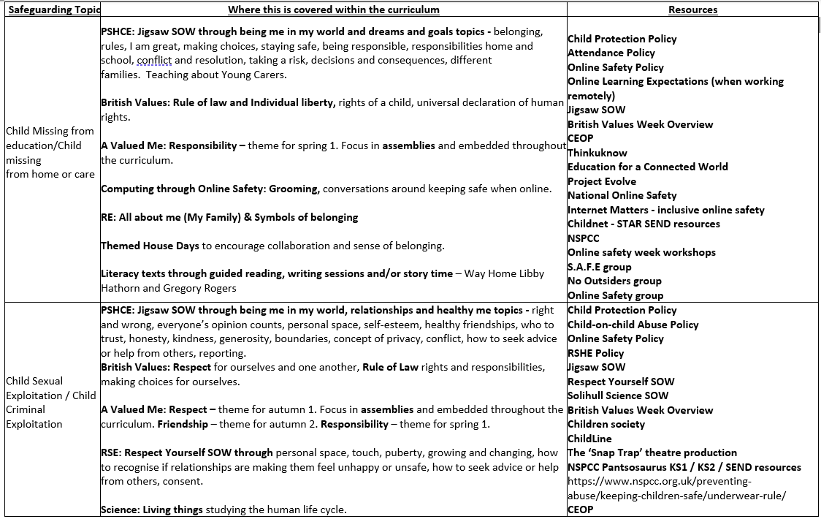
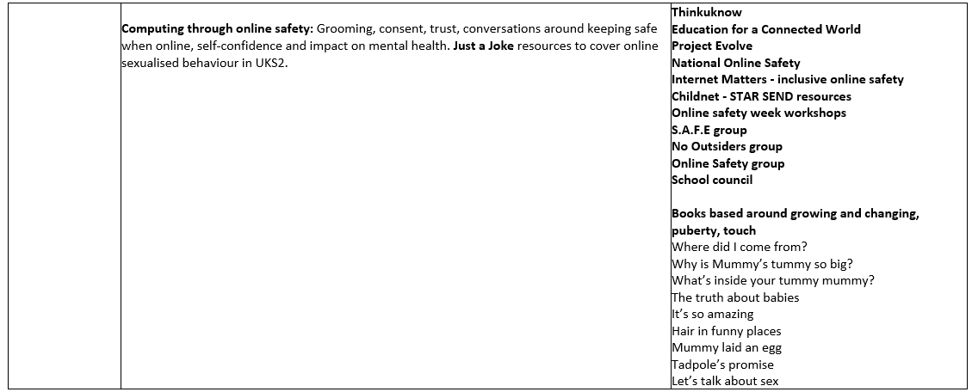

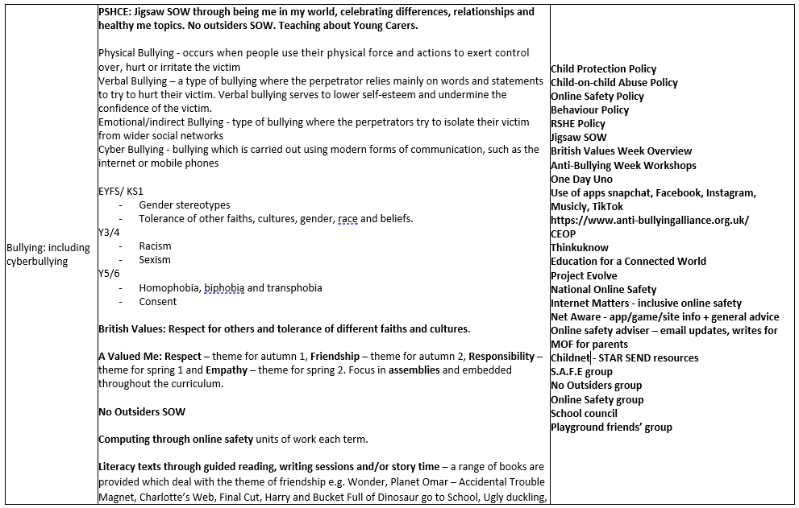
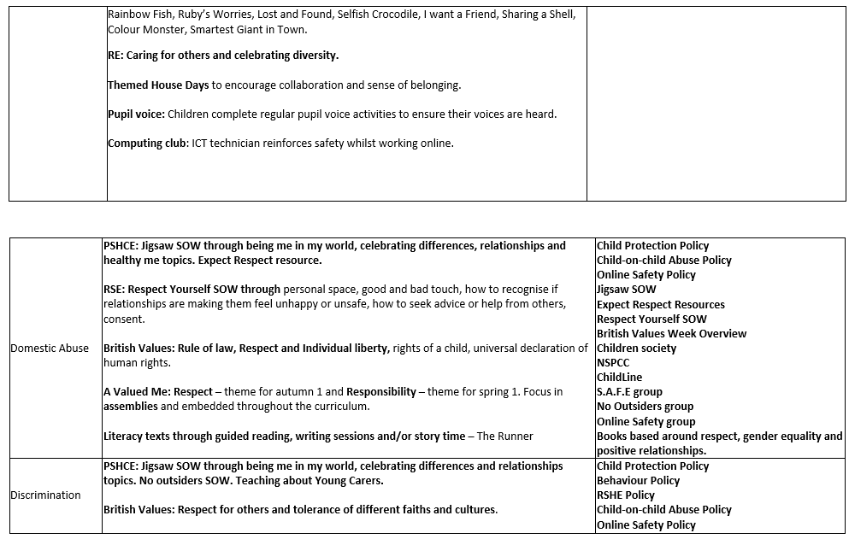

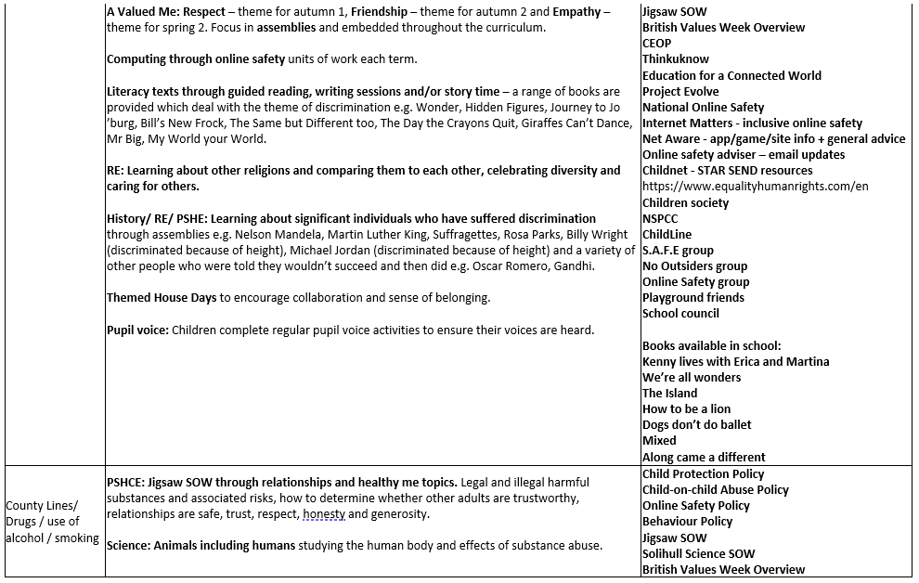
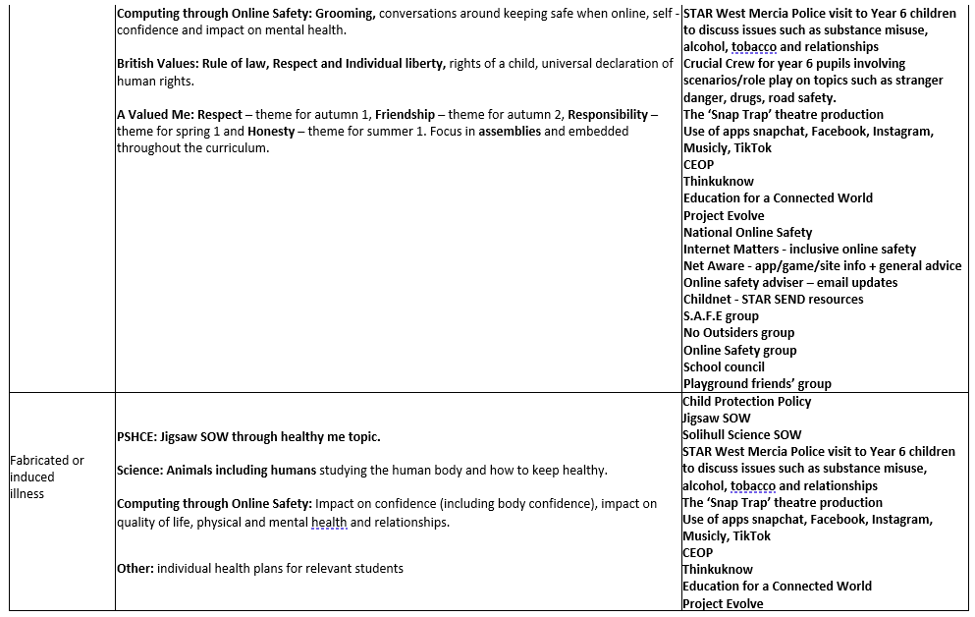

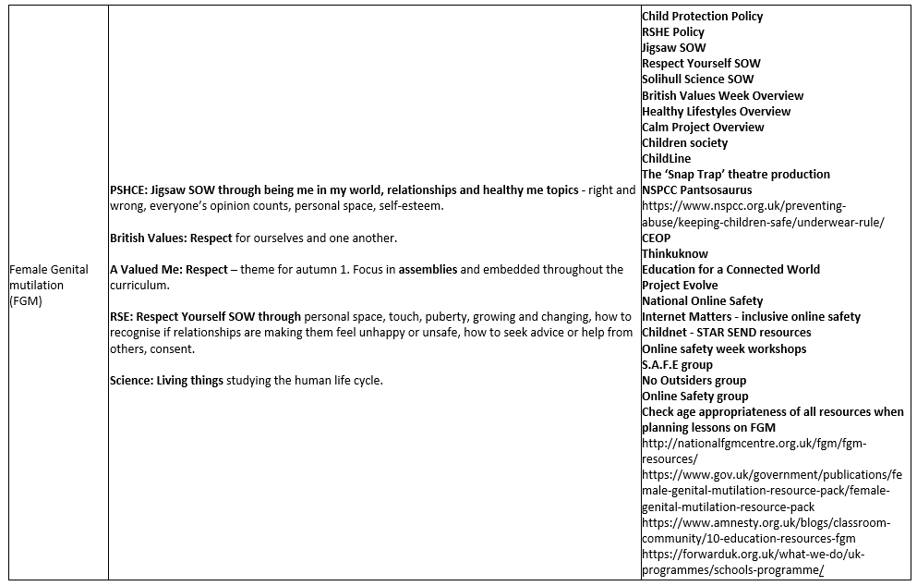
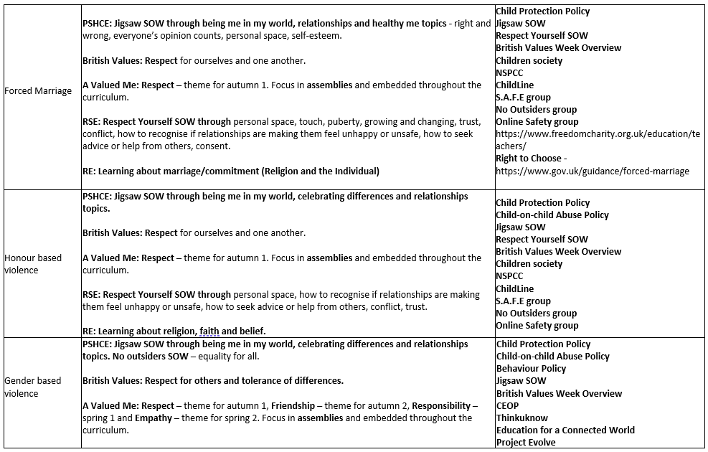
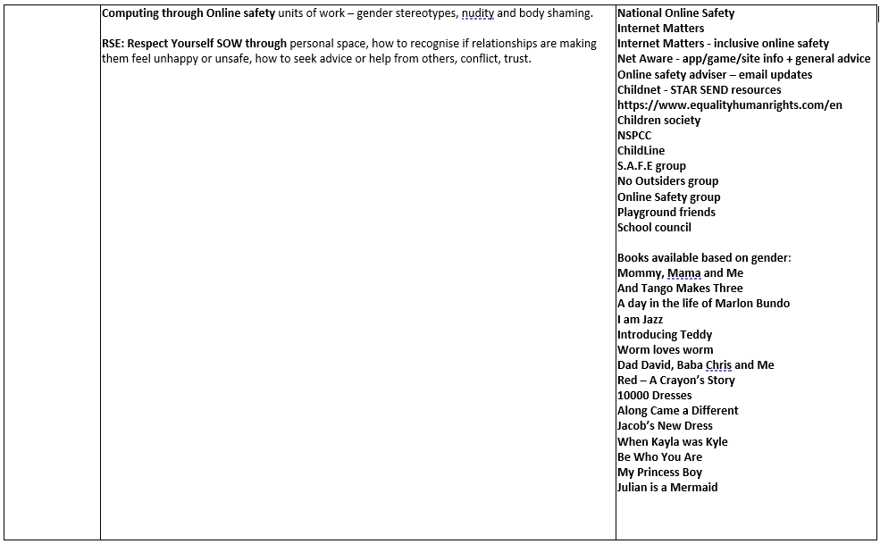
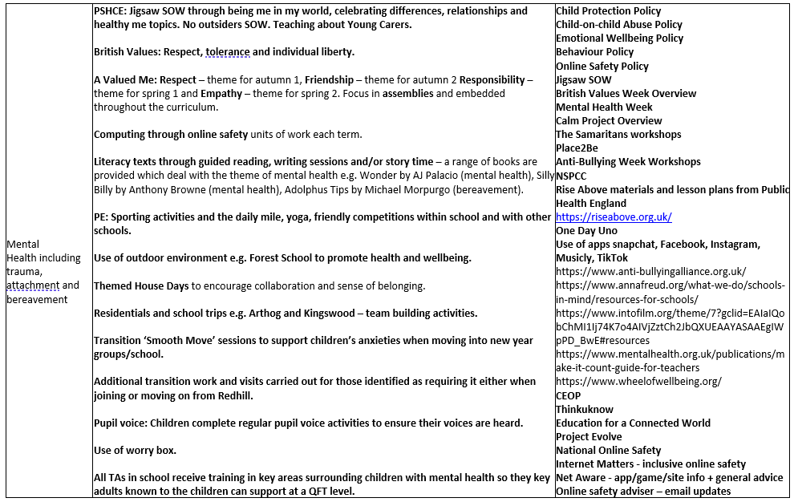
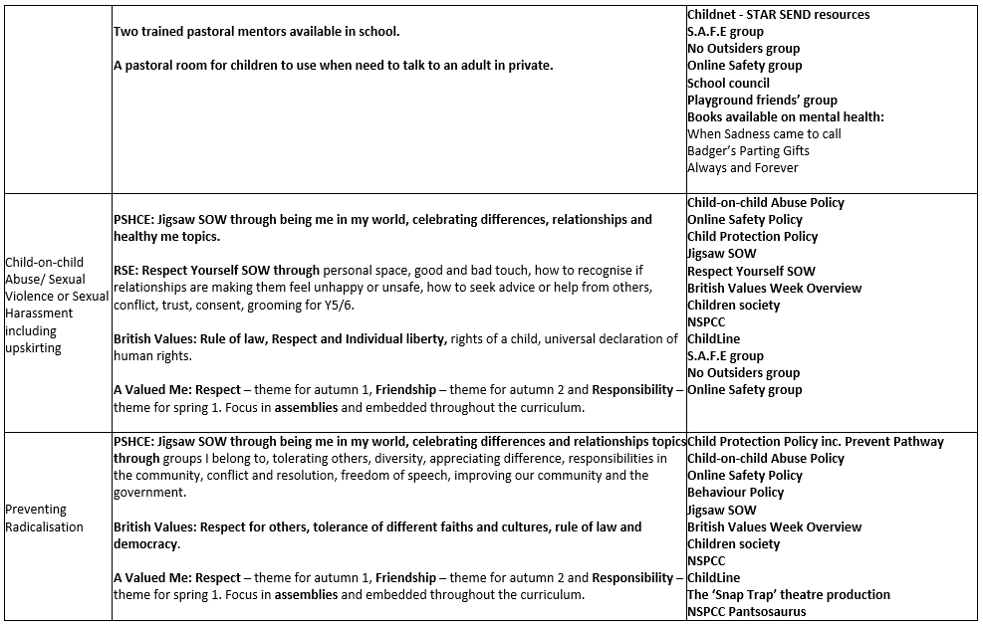
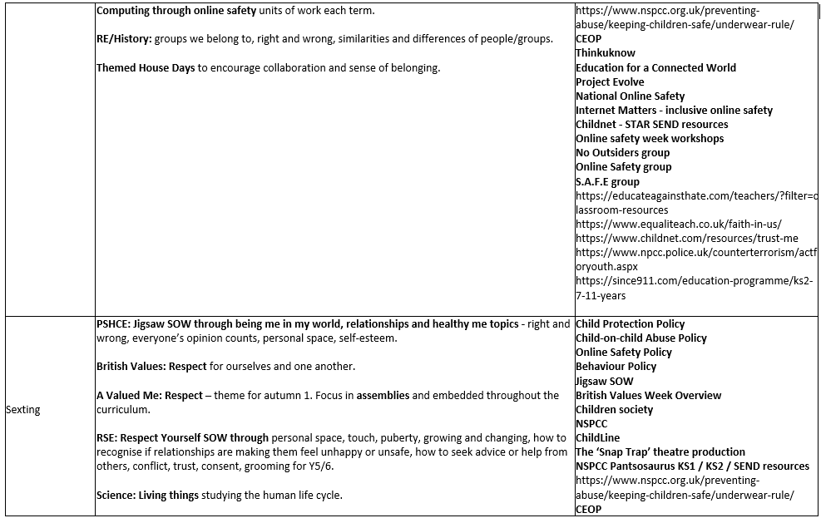
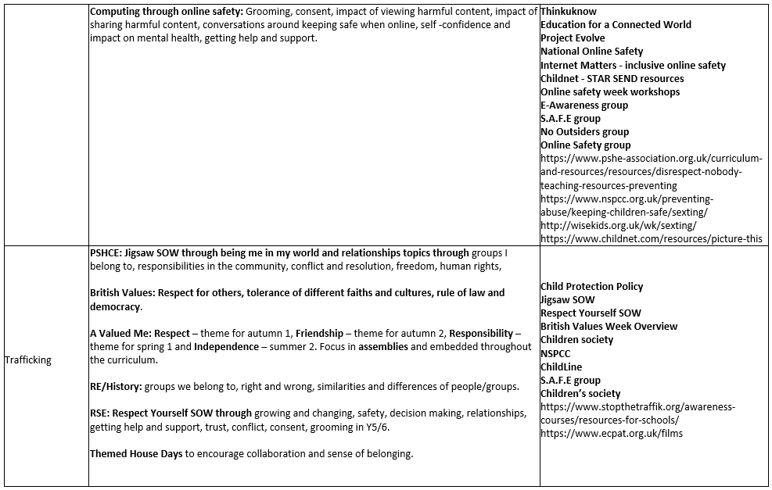
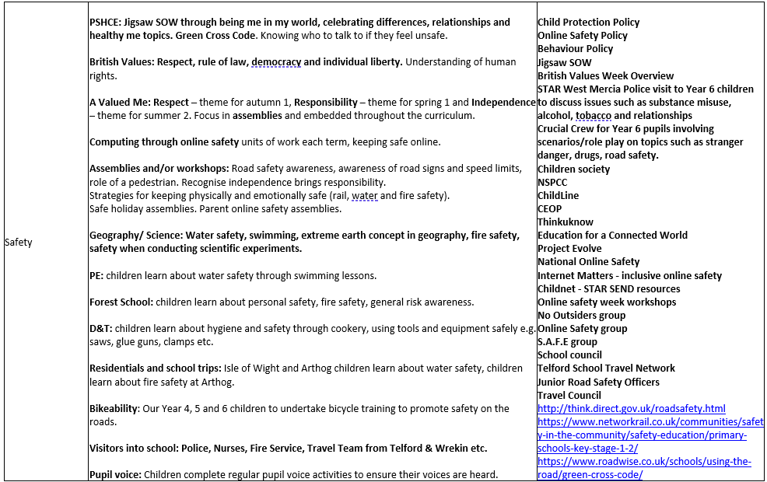
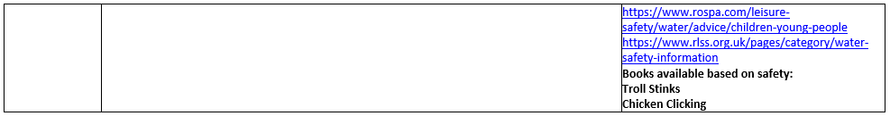

Online safety

- We recognise online safety is a major concern for all professionals.

- We believe it is essential that children are safeguarded from potentially harmful and inappropriate online material.

- The aim of our approach to online safety is empowerment to protect and educate pupils and staff in their use of technology and establish mechanisms to identify, intervene in, and escalate any concerns where appropriate. We will ensure appropriate filtering and monitoring on Academy devices and networks. We aim to protect children from illegal, inappropriate or harmful content, and harmful online interaction with other users. We aim for our pupils to exhibit positive personal online behaviour and recognise inappropriate online conduct. We aim to protect children from commercial risks.

- The breadth of issues classified within online safety is considerable, but can be categorised into four areas of risk:
- content: being exposed to illegal, inappropriate or harmful content, for example: pornography, fake news, racism, misogyny, self-harm, suicide, anti-Semitism, radicalisation and extremism.
- contact: being subjected to harmful online interaction with other users; for example: child to child pressure, commercial advertising and adults posing as children or young adults with the intention to groom or exploit them for sexual, criminal, financial or other purposes’.
- conduct: personal online behaviour that increases the likelihood of, or causes, harm; for example, making, sending and receiving explicit images (e.g. consensual and non-consensual sharing of nudes and semi-nudes and/or pornography, sharing other explicit images and online bullying; and
- commerce: risks such as online gambling, inappropriate advertising, phishing and or financial scams. If we feel our pupils, students or staff are at risk, we will report it to the Anti-Phishing Working Group (https://apwg.org/).

- We will ensure online safety is a running and interrelated theme whilst devising and implementing policies and procedures. This will include considering how online safety is reflected as required in all relevant policies and considering online safety while planning the curriculum, any teacher training, the role and responsibilities of the DSL (and deputies) and any parental engagement.

- We take seriously our duties to assist parents and help them with online safeguarding resources. As such, we will make them aware of relevant support services.

- Where children are being asked to learn online at home we will follow the advice to support schools and colleges do so safely: safeguarding in schools colleges and other providers and safeguarding and remote education. We recognise the NSPCC and PSHE Association also provide helpful advice.

- Through our regular communications with parents, we will reinforce the importance of children being safe online and tell parents what systems we use to filter and monitor online use. We will make parents aware of what their children are being asked to do online, including the sites we asked them to access. We will always be clear who from our Academy (if anyone) a child is going to be interacting with online.

- While considering our responsibility to safeguard and promote the welfare of children and provide them with a safe environment in which to learn, we will do all that we reasonably can to limit children’s exposure to risks from our IT system. We will ensure we have appropriate filters and monitoring systems in place. The leadership team and relevant staff, such as online safety lead will obtain an understanding of the filtering and monitoring provisions in place and manage them effectively and know how to escalate concerns when identified. We will do this by considering the age range of our children, the number of children, how often they access the IT system and the proportionality of costs versus risks.

- The appropriateness of our filters and monitoring systems have been informed in part, by the risk assessment required by the Prevent Duty. To meet this duty we will work to meet the digital and technology standards. We will:
- identify and assign roles and responsibilities to manage filtering and monitoring systems.
- review filtering and monitoring provision at least annually.
- block harmful and inappropriate content without unreasonably impacting teaching and learning.
- have effective monitoring strategies in place that meet safeguarding needs.

- We have the appropriate level of security protection in place; in order to safeguard our systems, staff and learners and we will review the effectiveness of these procedures periodically to keep up with evolving cyber-crime technologies.

- We will carry out an annual review of our approach to online safety, supported by an annual risk assessment that considers and reflects the risks their children face.

- Our local governing board will question school leaders to gain a basic understanding of our approach to keeping children safe online; learn how to improve this approach where appropriate; and find out about tools, which can be used to improve the approach.

- Mentors of trainee teachers and newly qualified teachers induct mentees and provide ongoing support, development and monitoring on online safety.

- Our information technology (IT) services provider uses monitoring software at the Academy and will be reviewed, updated and checked regularly. This addresses and includes all online risk of harm, including risks posed by the online activity of extremist and terrorist groups. On occasions, unacceptable websites might be accessed inadvertently; if this occurs then this should be closed down immediately and logged and reported to head teacher, designated safeguarding lead and to the IT services technician.

Redhill Primary Academy recognises that many children have unlimited and unrestricted access to the internet via 3G, 4G and 5G in particular. We will manage this by:
- teaching children about online safety;
- not allowing children to use personal electronic devices in Redhill Primary Academy;
- not allowing children to take images of other children or staff; and,
- only allowing children to access their personal electronic devices off the school premises.

The Redhill Academy network is protected at its perimeter by a regularly maintained firewall that is also tested externally for vulnerabilities. All internet traffic is filtered by specifically tailored filtering policies for Staff & Students. Logs of all internet activity are recorded by the IT Services Provider. Downloads are scanned for viruses prior to release on the network.

Internet filtering at Redhill Primary Academy is also supplemented with classroom monitoring software on all devices that actively monitors against a dictionary of sensitive words and phrases. Screen captures and usage on devices is automatically logged. Summaries of these logs are shared with designated staff and safeguarding.

Remote access to resources for staff and students is provided over encrypted services such as SSL VPN or the Microsoft O365 Platform.

Mobile and smart technology

- We recognise that many children have unlimited and unrestricted access to the internet via mobile phone networks. This access means some children, while at our setting sexually harass, bully, and control others, via their mobile and smart technology, share indecent images consensually and non-consensually and view and share pornography and other harmful content.

- Visitors and pupils are not allowed access to mobiles or smart technology. The policy is clearly stated to visitors through our signing in systems and to pupils via our acceptable use policy. Staff are informed through the induction process and regular through safeguarding staff meeting updates, that the use of mobile phones in the classroom is forbidden. They can only be used in the office/conservatory areas. Please see our policy on the safe use of mobile and smart technology. Please see our policy on the safe use of mobile and smart technology.

Inspection

- We recognise our responsibilities for safeguarding within the remit of Ofsted.

The use of ‘reasonable force’

- There are circumstances when it is appropriate for staff in our setting to use reasonable force to safeguard children and young people. The term ‘reasonable force’ covers the broad range of actions used by staff that involve a degree of physical contact to control or restrain children. This can range from guiding a child to safety by the arm, to more extreme circumstances such as breaking up a fight or where a young person needs to be restrained to prevent violence or injury. ‘Reasonable’ in these circumstances means us ‘using no more than is needed.’ Our use of force may involve either passive physical contact, such as standing between pupils or blocking a pupil’s path, or active physical contact such as leading a pupil by the arm out of the classroom.

- We will always follow the advice for schools on the Use of Reasonable Force in Schools. We will also have regard to additional guidance Reducing the Need for Restraint and Restrictive Intervention for children and young people with learning disabilities, autistic spectrum conditions and mental health difficulties in health and social care services and special education settings.

- We believe that the adoption of a ‘no contact’ policy in our setting could leave staff unable to fully support and protect our pupils and students. We will adopt a sensible approach allowing staff to make appropriate physical contact. The decision on whether to or not to use reasonable force to control or restrain a child is down to the professional judgement of the staff concerned and should always depend on individual circumstances.

- When using reasonable force in response to risks presented by incidents involving children with SEND, mental health or with medical conditions, we will consider the risks carefully because we recognise the additional vulnerability of these groups. We will consider our duties under the Equality Act 2010 in relation to making reasonable adjustments, non-discrimination and our Public Sector Equality Duty.

- We will plan positive and proactive behaviour support, for instance through drawing up individual behaviour plans for more vulnerable children, and agreeing them with parents and carers, we aim to reduce the occurrence of challenging behaviour and the need to use reasonable force. We will only use reasonable force where de-escalation processes have failed.

Hiring out our facilities and premises

- Where we hire or rent out our facilities/premises to organisations or individuals (for example to community groups, sports associations, and service providers to run community or extra-curricular activities) we will ensure that appropriate arrangements are in place to keep children safe.

- When services or activities are provided by us, under our own direct supervision or management, our own arrangements for child protection will apply. However, where services or activities are provided separately by another body this is not necessarily the case. We will therefore seek assurance that the body concerned has appropriate safeguarding and child protection policies and procedures in place including inspecting these; and ensure that there are arrangements in place to liaise with us on these matters where appropriate. We will also ensure safeguarding requirements are included in any transfer of control agreement (i.e., lease or hire agreement), as a condition of use and occupation of the premises; and that failure to comply with this may lead to termination of the agreement.

- The guidance on Keeping children safe in out-of-school settings details the safeguarding arrangements that schools and colleges should expect these providers to have in place.

- In any event where we feel there is reputational risk to our organisation, we will withdraw from any hire agreement of our premises. We will ensure the hirer acknowledges that our Academy has a duty under Section 26 of the Counter Terrorism and Security Act 2015 in the exercise of its functions to have “due regard to the need to prevent people from being drawn into terrorism” (the “Prevent Duty”). We will ensure the hirer uses our premises in such a way as to satisfy the Prevent Duty. We will take all reasonable steps to ensure our premises are not used by any groups or speakers in support of any extremist ideology.

Absent and missing from education

- We believe children being absent from education for prolonged periods and/or on repeat occasions can act as a vital warning sign to a range of safeguarding issues. Our response to persistently absent pupils and children missing education will support identifying such abuse, and in the case of absent pupils, helps prevent the risk of them becoming a child missing education in the future. This includes when problems are first emerging but also where children are already known to local authority children’s social care and need a social worker (such as a child who is a child in need or who has a child protection plan, or is a looked after child), where being absent from education may increase known safeguarding risks within the family or in the community.

- The recognised figure for severely absent is 50% or less and persistent absence is being less than 90%, although concerns may still be raised if above this. We will require the behaviour and attendance lead to refer to and use the established protocol document of notification to the Local Authority, filling out the appropriate paperwork, policies and procedures for identifying all pupils who are absent from education and policies and procedures for pupils on a modified timetable (available from Telford & Wrekin Council). We recognise that pupils who are not accessing full time education are at greater risk of abuse, neglect and exploitation than other children. We therefore aim to reduce the number of pupils accessing a modified timetable. We will ensure any pupils accessing a modified timetable are seen regularly by Academy staff to help to ensure their safety and welfare. It is our aim that pupils access modified timetables for the limited periods of time and children who on a child protection, child in need plan and/or have an Education Health Care Plan are not placed on a modified timetable. We will regularly monitor and review the use of modified timetables.

- In addition to the above and where reasonably possible we will endeavour to hold more than one emergency contact number for each pupil. This goes beyond the legal minimum and is good practice to give us additional options to make contact with a responsible adult when a child is absent from education and poses a potential welfare/safeguarding concern. Where a child is on a Child Protection Plan has been missing from school for two consecutive days, we will notify the child’s allocated social worker.

- Where children leave the classroom or leave our grounds without permission, this is covered within our behaviour management policy and is also set against the backdrop of the legal framework of the Children Act 1989 s3 (5); ‘Anyone who has care of a child without parental responsibility may do what is “reasonable” in all the circumstances to safeguard and promote the child’s welfare. It is likely to be “reasonable” to inform the police, or children’s services departments, and, if appropriate, their parents, of the child/young person’s safety and whereabouts’. However, in principle, if a pupil runs out of class we will establish where he or she has gone. Staff will not run after them but will seek additional support. It is advisable to keep a watchful eye on any children who has taken themselves out of our building and possibly out of our grounds, unless this watchful eye provokes the child to run further. It is and will be a judgement call for staff to take what they feel is reasonable action in line with the advice above. If a child is no longer on the premises, we will contact parents in the first instance. If they are not contactable, we will inform the police that a pupil has left and is at risk.

- Where children go missing, including leaving school without permission, we will follow the West Mercia Pathway for Children who go Missing from Home, care or Education. We always deem it appropriate to report pupils who go missing from Redhill Primary Academy to the Police and children’s services where we or parents cannot locate the child quickly.

Elective Home Education (EHE)

- We understand that many home educated children have a positive learning experience. We would expect that any parents’ decision to home educate to be made with their child’s best education at the heart of the decision. However, we know this is not the case for all. Elective home education can mean that some children are not in receipt of suitable education and are less visible to the services that are there to keep them safe and supported in line with their needs.

- From September 2016 the Education (Pupil Registration) (England) Regulations 2006 were amended. This means we inform Telford & Wrekin Council of all deletions from our admission register when a child is taken off roll.

- Where a parent/carer has expressed their intention to remove a child from school with a view to educating at home, we will facilitate a meeting with the local authority education team, ourselves and other relevant schools, other key professionals and where possible parents/carers. Ideally, this will be before a final decision has been made, to ensure the parents/carers have considered what is in the best interests of each child. This is particularly important where a child has SEND, is vulnerable, and/or has a social worker. We will invite the local authority education team by emailing ehe@telford.gov.uk

- Where parents intend to electively home educate their child/ren, we will work with the local authority elective home education team to consider, plan for and ensure ongoing support for the child’s safeguarding and welfare needs at the point the child/ren become electively home educated.

- We understand it is our responsibility to identify parents or carers who we need to meet with to discuss EHE before they make their final decision. We will record if parents refuse to attend this meeting. If parents decline this meeting, we will still meet with the local authority.

- We will follow the Telford & Wrekin Council, EHE pathway.

Children who need a social worker (Child in Need and Child Protection Plans)

- Children may need a social worker due to safeguarding or welfare needs. Children may need this help due to abuse and/or neglect and/or exploitation and/or complex family circumstances. A child’s experiences of adversity and trauma can leave them vulnerable to further harm, as well as educationally disadvantaged in facing barriers to attendance, learning, behaviour and mental health.

- Local authorities should share the fact a child has a social worker, and the DSL will hold and use this information so that decisions can be made in the best interests of the child’s safety, welfare and educational outcomes.

- Where children need a social worker, this information will be used by the DSL (or deputies) to inform decisions about safeguarding (for example, responding to unauthorised absence or missing education where there are known safeguarding risks) and about promoting welfare (for example, considering the provision of pastoral and/or academic support, alongside action by statutory services).

Children requiring mental health support

- We recognise that we have an important role to play in supporting the mental health and wellbeing of our pupils.

- Mental health concerns can, in some cases, be an indicator that a child has suffered or is at risk of suffering abuse, neglect or exploitation. The local governing board have put clear systems and processes in place for identifying possible mental health concerns, including routes to escalate and clear referral and accountability systems.

- We will help prevent mental health concerns by promoting resilience as part of our integrated, whole setting approach to social and emotional wellbeing, which is tailored to the needs of our pupils.

- Our senior mental health lead is Denise Rock. The appointed member who supports our senior mental health lead is Faye Bailey.

- Please see our Emotional Health and Wellbeing Policy for children and young people at https://redhill.ttsonline.net/page/policies for further information.

Suicide Intervention

- We accept and understand that thoughts of suicide are common and the leading cause of death in young people. As such, suicide intervention is our business too. We to work with our pupils and work in partnership to support anyone in our community that may have thoughts of suicide. We will follow our Suicide Intervention Policy to assist wherever we can in making those in our care as safe as is possible. We will also make staff aware of the following useful link in raising awareness of the subject http://zerosuicidealliance.com/

Looked after children and previously looked after children

- We recognise that the most common reason for children becoming looked after is as a result of abuse and/or neglect. All staff at our setting have the knowledge and skills to keep looked after children safe. The DSL will hold the details of each child’s social worker and the name of the virtual school head in the authority that looks after the child. They are responsible for ensuring all staff have the information they need in relation to a child’s looked after status and the child’s contact arrangements with birth parents or those with parental responsibility. They will also have information about the child’s care arrangements and the levels of authority delegated to the carer by the authority looking after him/her and for championing the educational attendance, attainment and progress of children in kinship care.

- We recognise a previously looked after child potentially remains vulnerable. When dealing with looked after children and previously looked after children we will work with all agencies to take prompt action where necessary to safeguard these children.

The designated teacher

- The local governing board appoint Lisa Williams as the designated teacher to work with the local authorities to promote the educational achievement of registered pupils who are looked after. With the commencement of sections 4 to 6 of the Children and Social Work Act 2017, designated teachers have responsibility for promoting the educational achievement of children who have left care through adoption, special guardianship or child arrangement orders or who were adopted from state care outside England and Wales. The designated teacher has appropriate training and relevant qualifications and experiences to fulfil this role.

- We will follow the statutory guidance on The Roles and Responsibilities of the Designated Teacher.

Virtual school heads

- As an Academy, the designated teacher will work with the virtual school head to discuss how funding can be best used to support the progress of looked after children in the school and meet the needs identified in the child’s personal education plan. The designated teacher also works with the virtual school head to promote the educational achievement of previously looked after children.

- The Virtual School Head strategic role will also include:
a) Raising the visibility of the distinct needs of children in different types of kinship care arrangements and the disadvantage that they can experience.
b) Promoting practice that supports attendance and engagement in education.
c) Promoting practice that improves children in kinship care’s outcomes to narrow the attainment gap, so that every child has the opportunity to reach their full potential.

- We will follow the statutory guidance on Promoting the Education of Looked After Children.

- The DSL, Headteacher, governors, SENCO and senior mental health lead will work with the virtual school head to promote educational attendance, attainment and progress of children with a social worker.

- The virtual school head for Telford and Wrekin is Michelle Salter.

Children who have special educational needs and disabilities (SEND) or health issues

- We recognise that children who have SEND or certain health or physical health conditions can face additional safeguarding challenges. We accept the additional barriers that can exist when recognising abuse, neglect and exploitation of children in this group of children. These can include:
- assumptions that indicators of possible abuse such as behaviour, mood and injury relate to the child’s disability without further exploration;
- being more prone to peer group isolation than other children;
- the potential for children with SEND being disproportionally impacted by behaviours such as bullying, without outwardly showing any signs; and
- communication barriers and difficulties in overcoming these barriers.

- To help address these additional challenges we will provide extra pastoral support for children with SEND. For any reports of abuse involving children with SEND, the DSL (or a deputy) and the SENCO will liaise closely.

Children who are lesbian, gay, bisexual, or gender questioning

This section of our policy remains under review, pending the outcome of the gender questioning children guidance consultation, and final gender questioning guidance documents being published.

- We recognise that a child or a young person being lesbian, gay, or bisexual is not in itself an inherent risk factor for harm. However, they can sometimes be targeted by other children. In some cases, a child who is perceived by other children to be lesbian, gay, or bisexual (whether they are or not) can be just as vulnerable as children who identify as LGBT.

- The Cass review identified that caution is necessary for children questioning their gender as there remain many unknowns about the impact of social transition and children may well have wider vulnerabilities, including having complex mental health and psychosocial needs, and in some cases additional diagnoses of autism spectrum disorder and/or attention deficit hyperactivity disorder.

- It recommended that when families/carers are making decisions about support for gender questioning children, they should be encouraged to seek clinical help and advice. When parents are supporting pre-pubertal children, clinical services should ensure that they can be seen as early as possible by a clinical professional with relevant experience.

- When supporting a gender questioning child, we will take a cautious approach and consider the broad range of their individual needs, in partnership with the child’s parents (other than in the exceptionally rare circumstances where involving parents would constitute a significant risk of harm to the child), including any clinical advice that is available and how to address wider vulnerabilities such as the risk of bullying.

- Risks can be compounded where children who are lesbian, gay, or bisexual lack a trusted adult with whom they can be open. All staff will endeavour to reduce the additional barriers faced and create a culture where they can speak out or share their concerns with members of staff.

Staff

- All staff, supply staff, contractors and visitors, are informed of the name of the DSL and deputies and our procedures for protecting children, for example, how to report their concerns, suspicions and how to receive, record and report disclosures.

- Staff should not accept personal invitation visits to the homes of children unless permission or instruction has been sought from the Headteacher and it is viewed as a professional appointment, for example, supporting education welfare issues etc. This should be viewed on a case-by-case basis. To support this, guidance from the Department of Education (September 2010) states ‘Meetings with pupils away from the school premises should only be arranged with the specified approval of the head teacher and the prior permission of the pupil in question’. We accept this guidance from the Department of Education (September 2010) stating that in the case of private meetings; ‘Staff and volunteers should be aware that private meetings with individual pupils could give cause for concern. There will be occasions when a confidential interview or a one-to-one meeting is necessary. Such interviews should be conducted in a room with visual access or an area which is likely to be frequented by other people. Another pupil or adult should be present or nearby. Where conditions cannot apply, staff should ensure that another adult knows that the interview is taking place’.

Parents

- Parents play an important role in protecting their children from abuse. We are required to consider the safety of the child and should a concern arise, professional advice may be sought prior to contacting parents. If deemed appropriate, parents will be contacted, and we will continue to work with them to support the needs of their child. Consent from the parents will be sought, although in exceptional circumstances and with the best interests of the child being considered, this may be overridden.

- We aim to help parents to understand their responsibility for the welfare of all children, which includes their duty to refer cases to social care services and/or police in the interests of the child. The local governing board will include a child protection statement in our prospectus and all parents can view a copy of this policy.

- Parents that have concerns regarding a member of staff can in the first instance raise those with the Headteacher. This may involve sharing those concerns with the relevant agencies. Where the parent has concerns regarding the Headteacher, the chair of governors should be consulted in the first instance.

- Parents can liaise with Ofsted on such conduct issues or regulatory concerns, advice can be found on its website www.ofsted.gov.uk.

- On occasions Ofsted may forward complaints that may raise a safeguarding concern about our school via Family Connect. In such instances, we will work with all agencies within Family Connect to clearly respond to Ofsted on a case-by-case basis.

- Parents/Carers can also access Ofsted Parent View which is an online survey questionnaire where parents can give their views. Where possible, this will be monitored regularly by the Academy to quickly address any concerns.

- Parents can liaise with the Independent Schools Inspectorate (ISI) on such conduct issues or regulatory concerns, advice can be found on its website https://www.isi.net/parents-and-pupils/concerns-about-a-school or contact can be made direct to ISI, you can email concerns@isi.net or call 020 7600 0100 and ask to talk to an appropriate member of staff.

- All complaints should be made via our complaint’s procedures.

- We will keep parents informed of all areas of safeguarding and child protection through the regular methods of communication.

- We wish to make it clear to parents the standards, behaviour and respect we expect from them and conversely from us. If a parent’s behaviour is a cause for concern, then we will ask them to leave our premises. We wish to make it clear that in serious cases, the head teacher can notify parents in writing that their implied licence to be on our premises is temporarily revoked, subject to any representations that the parent may wish to make. This setting will give parents the opportunity to formally express their views on the decision to bar in writing and this will be reviewed via the complaints policy.

- Our setting is a private place. We will therefore act to ensure they remain a safe place for all. The public has no automatic right of entry.

- We expect parents to talk to us about any concerns they have about care and education provided by us in the first instance. We urge all parents not to express these concerns on social media platforms, at least not before sharing these concerns with us first.

Changing in school

- We consider arrangements for safe changing of children for physical education (PE). We will be guided by the NSPCC guidance Best Practice for PE Changing Rooms. This consideration will come under our duty and remit of health & safety and in the context of children’s welfare. We follow the guidance and do what we need to do in relation to organising changing facilities for children; staff supervision; changing areas for children with additional needs; changing considerations for drama productions and using off-site changing rooms. NSPCC factsheet

Part three: Safer Recruitment

- We will meet all requirements as set out in Part three: Safer recruitment KCISE.

- We commission Browne Jacobsonhuman resources service to assist in the management of safer recruitment procedures.

- Please see our safer recruitment procedures in our safer recruitment policy here: https://redhill.ttsonline.net/page/safeguarding-at-redhill-redhill-safeguarding.aspx

Recruitment and selection process

- We aim to create a culture that safeguards and promotes the welfare of all children. As part of this culture, we will adopt robust recruitment procedures that help to deter and prevent people who are unsuitable to work with children from applying for or securing employment, or volunteering opportunities in our setting.

- We will ensure that all those involved with the recruitment and employment of staff to work with children have received appropriate safer recruitment training. As a result, all interview panel members will have completed safer recruitment training.

The following persons have completed safer recruitment training:

Sam Farmer (7/11/2023)

Zara Bate (24/11/2022)

Claire Whiting (02/02/22)

Lydia Cartwright (24/11/2022)

Phil Nicholls (01/09/2020) Governor

Dara Carroll (26/11/2020) Admin only

Pre-appointment vetting checks, regulated activity and recording information

- We will abide by the legal requirements when appointing individuals to engage in regulated activity relating to children. We understand the importance of ensuring the correct pre-appointment checks are carried out. These checks will help us to identify whether a person may be unsuitable to work with children (and in some cases is legally prohibited from working with children and/or working as a teacher). We see this as part of our wider safeguarding regime which will carry on following appointment.

Other checks that may be necessary for staff, volunteers and others

- We will carry out the checks that are necessary for individuals who have lived or worked outside the UK; agency and third-party staff; contractors; trainee teachers; volunteers; governors and proprietors. We will fulfil our responsibilities in relation to other settings, including alternative provision, work experience and host families.

Visitors

- We have different types of visitors, those with a professional role, those connected with the building, grounds maintenance, children’s relatives or other visitors attending an activity.

- We will not request DBS checks or barred list checks, or ask to see existing DBS certificates, for visitors such as children’s relatives or other visitors attending a sports day. The Headteacher/Principal will use their professional judgment about the need to escort or supervise such visitors.

- For visitors who attend our setting in a professional capacity we will check their ID and seek assurance that the visitor has had the appropriate DBS check (or the visitor’s employers have confirmed that their staff have appropriate checks). We will not ask to see DBS certificates.

- While external organisations can provide a varied and useful range of information, resources and speakers that can help us enrich children’s education; careful consideration will be given to the suitability of any external organisations.

Alternative provision

- Where we place a pupil with an alternative provision provider, we continue to be responsible for the safeguarding of that pupil and will undertake checks to be satisfied that the provider meets the needs of the pupil.

- We will obtain written confirmation from the alternative provider that appropriate safeguarding checks have been carried out on individuals working at the establishment.

- Please see our Alternative provision policy.

Adults who supervise children on work experience

- When organising work experience placements, we will ensure that the placement provider has policies and procedures in place to protect children from harm.

- Children’s barred list checks via the DBS might be required on some people who supervise a child under the age of 16 on a work experience placement. We will consider the specific circumstances of the work experience and give consideration in particular to the nature of the supervision and the frequency of the activity being supervised, to determine what, if any, checks are necessary. These considerations will include whether the person providing the teaching/training/instruction/supervision to the child on work experience will be:
- unsupervised themselves, and
- providing the teaching/training/instruction frequently (more than three days in a 30- day period, or overnight).
If the person working with the child is unsupervised and the same person is in frequent contact with the child, the work is likely to be regulated activity relating to children. If so, we may ask the employer providing the work experience to ensure that the person providing the instruction or training is not a barred person.

- We are not able to request that an employer obtains an enhanced DBS check with children’s barred list information for staff supervising children aged 16 to 17 on work experience. If an activity undertaken by a child on work experience takes place in a ‘specified place’, such as a school or sixth form college, and gives the opportunity for contact with children, this may itself be considered to be regulated activity relating to children.

Children staying with host families (homestay)

- If we arrange a homestay, we will consider the suitability of the adults in the respective families who will be responsible for the visiting child during the stay.

- We will always consider what intelligence/information will best inform our assessment of the suitability of the adults in those families who will be responsible for the visiting child during the stay. We will use our professional judgement to decide what will be relevant. To help inform our assessment, we will obtain a DBS enhanced certificate with barred list information. This check will not only establish whether the adults are barred from engaging in regulated activity relating to children, but where criminal record information is disclosed, it will also allow us to consider, alongside all other intelligence that we have obtained, whether the adults would be a suitable host for a child. We will also decide whether it is necessary to obtain a DBS enhanced certificate in respect of anyone aged 16 or over in the household where the child will be staying.

Host families – homestay during exchange visits

- We have a duty to safeguard and promote children’s welfare. This extends to considering their safety and how best to minimise risk of harm to those children during any exchange visit we arrange, and when organising for the care and accommodation of a child with a host family (known as homestays) as part of the exchange.

- We will follow the guidance set out in Annex E of KCSIE with regard to arranging homestay – suitability of adults in UK host families, homestay – suitability of adults in host families abroad and the additional action for extended homestays.

- We will always ensure pupils understand who to contact during a homestay, should an emergency occur, or a situation arise which makes them feel uncomfortable.

Private fostering

- We recognise that a private fostering arrangement occurs when a child under the age of 16 (under 18, if disabled) is provided with care and accommodation by a person who is not a parent, person with parental responsibility for them or a relative in their own home.

- A child is not privately fostered if the person caring for and accommodating them has done so for less than 28 days and does not intend to do so for longer. Such arrangements may come to the attention of school staff through the normal course of their interaction, and promotion of learning activities, with children.

- By law, a parent, private foster carer or other persons involved in making a private fostering arrangement must notify children’s social care as soon as possible. If we become aware of a private fostering arrangement for a student that has not been notified to children’s social care, we will encourage parents and private foster carers to notify them and will share information with children’s social care as appropriate.

Our ongoing safeguarding of children and the legal reporting duties on us

- We understand the importance of safeguarding vigilance beyond the recruitment process.

- We believe safer recruitment is not just about carrying out the right DBS checks. Similarly safeguarding should not be limited to recruitment procedures. Good safeguarding requires a continuing commitment from our whole community to ensure the safety and welfare of children is embedded in all of our processes and procedures, and consequentially enshrined in our ethos.

- We aim to promote continuous vigilance, maintaining an environment that deters and prevents abuse and challenges inappropriate behaviour.

- We aim to create the right culture and environment so that our staff feel comfortable to discuss matters both within, and where it is appropriate, outside of the workplace, which may have implications for the safeguarding of children. This can help assist us as employers to support staff, where there is a need, and help them manage children’s safety and welfare. Potentially providing them with information that will help them consider whether there are further measures or changes to procedures that need to be put in place to safeguard children in our care.

- We will undertake our duty to refer to the Disclosure and Barring Service and to the Teaching Regulation Agency where required.

